25 ‘Things to do’ at home
This is a list of activities that you can work on with your child throughout their time at home. Some of these activities may not be possible for you to do with your child due to home demands and your child’s needs and that is fine but I just wanted you to have a few activities at hand that involve using resources at home and can develop your child’s interaction and communication skills as well as their independence. You don’t need to do these in any specific order and I look forward to seeing the photographs that capture these memories when we return!
- Doing the laundry.  Encourage your child to help you to load and unload the washing machine.  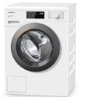 | 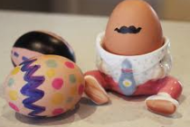  - Decorate an egg.  Hard boil an egg and then let your child decorate this with your child ready for number 5. | 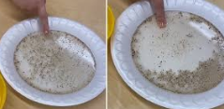  - Germ experiment.  Put black pepper into a bowl of water. Get your child to put their finger in it. The black pepper will stick to their finger. Then get them to place their finger into soap then back into the black pepper. It should stay away. | - Practise washing hands and face.  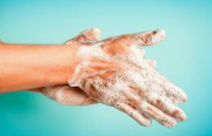  Practise using soap, water and also washing their faces with cloths. You can repeat this and practise singing, “Wash, wash, wash your hands. Wash the germs away. If you don’t you might get ill and that will spoil your day.”  (tune Row your boat) | - Egg rolling.  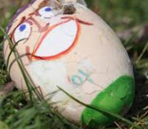  Take your hardboiled, decorated egg to a local area with a hill that you can roll your egg down. Does your egg survive? You can then go on to visit a park or have a picnic.
- Hoovering.  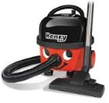  Give your child the opportunity to use the hoover and hoover your living room for you. | - Make binoculars.  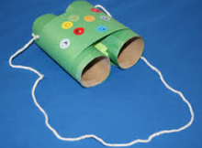  Using empty kitchen roll tubes make binoculars so your child is ready for their nature hunt on number 10. | - Take a photograph.  Hold a photograph session using a camera, a mobile phone, tablet or an iPad. Will you photograph your family, toys or pets? | - Obstacle course.  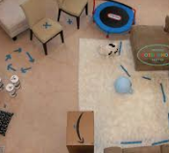  Create an obstacle course in your home or garden to practise moving at different heights e.g. crawling or tip toeing. | 10. Nature hunt.  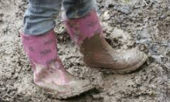  Go on a local walk to practise stopping when asked in the community. Remember to take your binoculars and see what nature you can find.
- Washing the pots.  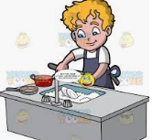  After breakfast, dinner or teas wash the pots that are not breakable. | 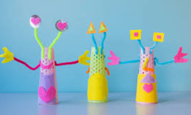  12. Junk modelling.  Using recyclable materials from around the house make a junk model. Let your child use tape and other materials as independent as possible. | 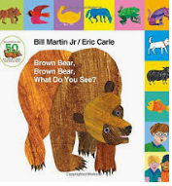  13. Share a story.  Choose your favourite story book or on the iPad and listen to the story being read. A familiar favourite is Brown Bear, Brown Bear. | 14. Keep moving!  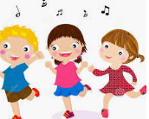  Join in with action rhymes, action songs or dance to your favourite song! | 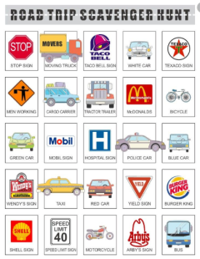  15. Road trip hunt.  Go on a walk or a drive and look for specific items. How many different types of transport or shops can you see?
16. Put your socks and shoes on.  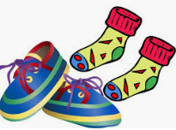  Practise putting your own shoes and socks on and taking them off. | 17. Salt dough models.  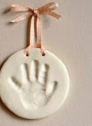  Make salt dough with 1 cup of salt 1 cup of plain flour and half a cup of water. Play with the salt dough and then make hand prints/foot print memorials. | 18. Mark making.  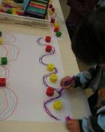  Using different writing tools such as colouring pens, paint or pencils can you make marks following patterns or letter shapes? | 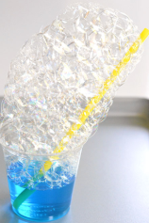  19. Bubble mountain.  Put a small amount of water and a drop of washing up liquid in a bowl. Using a straw blow to make a bubble mountain. | 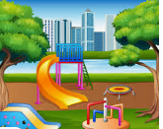  20. Play park or local woods.  Take a local trip to the park, woods or field to play.
21. Put your coat on and zip it up.  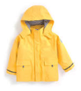  Practise putting your own coat on and practise zipping it up. | 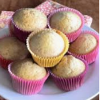  22. Baking buns or biscuits.  Make scones, biscuits or buns together and then enjoy them with a glass of juice. | 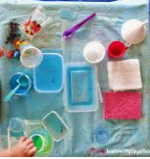  23. Make mud pie or water play.  Make a mud pie whilst playing in the garden or have a bowl of water to play with sponges and cups. | 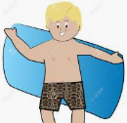  24. Try to dry.  After a bath or shower can you try and dry yourself using a towel? | 25. Bike ride, scooter ride or walk.  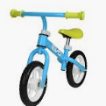  Go on a local bike ride, scooter ride or walk with your close family.

