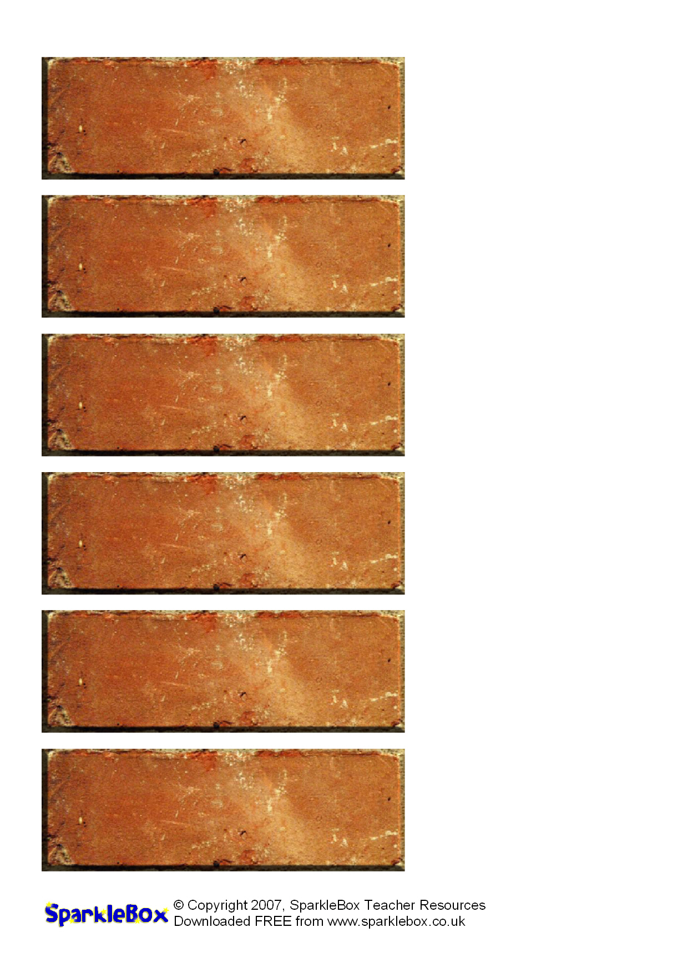
[Word]
[Word]
[Word]
[Word]
[Word]
[Word]

