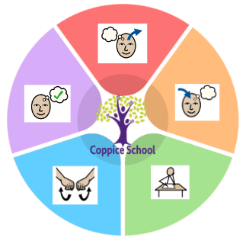
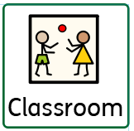
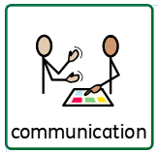
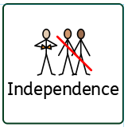
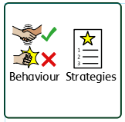

Happy Centred Schools Driver
Coping
and
Positive Relationships

Class: Catepillars
Pathway: Semi-Formal
Term:Summer 1
ENGLISH
Class Focus:

MATHS

DT
Strand:Cooking
Class Focus:trying different foods

ART
Strand: 3D
Class Focus:

GEOGRAPHY
Strand:
Class Focus:My World

Science
Strand:
Class Focus:Animals

MY WORLD
RSE

PSHE

Overarching EHCP
Life-Long learning
Physical & Sensory
Cognition & Learning
Communication & Interaction
Social, Emotional & Mental Health
Developing Independence
Books:
Brown Bear Brown Bear,
Farmyarh Hullabaloo

To support pupils to have a voice we will use…
Communication books, PECS cards, Communication boards. Verbal, gesture and visual aids.
To support pupils to develop independence we encourage…
Making our own drinks
Carrying our own lunch boxes
Hanging up our coats and putting our things away in the cloakroom
Composite Half Termly End Point:
Red:Make models using malleable materials. Stick two surfaces together.
Yellow:Create simple representations of events, people and objects combining materials together
Blue:Select tools for a purpose and make models using malleable materials.
Composite Half Termly End Point:
Red:Observe what animals do moving animals along a track
Yellow:Recognise and match animals to pictures moving them along a map
Blue:Name some habitats and respond to movement terms such as fast, slow.
Composite Half Termly End Point:
Red:I can recognise familiar animals. I closely observe what animals do, on film, in real life and small world. I am beginning to copy actions, noises and movements in relation to animals.
Yellow:I can copy adults sounds using small world animals. I can use an object to give an animal food. I m beginning to notice detailed features about animals.
Blue:I can identify common animal sounds and name simple body parts. I look closely at animals similarities, differences, patterns and change. I can talk about animals habitats.
Composite Half Termly End Point:
Red:Accept a variety of food exploring different textures such as wet, dry, fizzy.
Yellow:Sort foods into groups, make changes to foods or drink such as their colour.
Blue:Make a meal or snack with adult support
Composite Half Termly End Point:
Red:Show awareness of myself and my body parts
Yellow:Show an understanding of the cause of some feelings
Blue:Tell someone if I am feeling unwell or upset
Composite Half Termly End Point:
Red:Take pat in hygiene routines with support
Yellow:Take pat in hygiene routines using yes and no
Blue:Understand what is important to maintain a healthy body

Communication Half Termly End Point:
Red:
Yellow:
Blue:

Reading Half Termly End Point:
Red:
Yellow:
Blue:

Writing Half Termly End Point:
Red:
Yellow:
Blue:

Strand 1: Numbers set 2
Half Termly End Point:
Red:I can make sets with one and with lots of objects. I can identify one or two objects. I can hand over money in payment for something with full adult prompts.
Yellow:I can group objects. I understand more / less and can show what zero looks like. I can match and use coins up to 5p. I can add and take away one.
Blue:I can add two groups to find the total. I can take away objects and find the remainder. I can estimate a small number and check by counting. I am beginning to use ordinal numbers e.g. 1st 2nd 3rd

Strand 1: Measures set 3
Half Termly End Point:
Red:I can fill and empty containers.
Yellow:I explore full, empty and the same.
Blue: I compare the capacity of two containers saying which olds more, less or the same. I can order objects by size.

Composite Half Termly End Point:
Red:demonstrate an understanding of stillness and quiet
Yellow: Engage in moments of reflection
Blue:Demonstrate an understanding of right and wrong

RE

PE
Strand:Striking and fielding

Composite Half Termly End Point:
Red: Stop and start and avoid obstacles while running. Turn without looing balance. Throw a beanbag
Yellow:Throw, roll and receive a ball. Catch a ball in my arms.
Blue:Hit a ball with a bat. Send a ball with clear direction.

