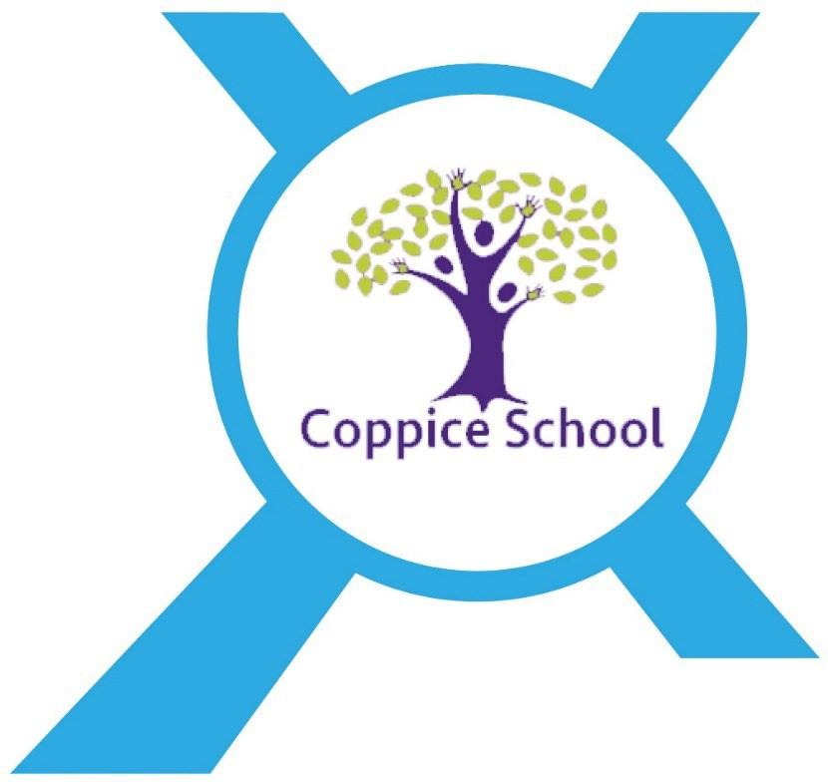

# Careers Education, Information and Guidance Policy

|  |  |
| --- | --- |
| **Date Published** | **June 2020** |
| **Version** | **3** |
| **Approved Date** | **July 2025** |
| **Review Cycle** | **Annual** |
| **Review Date** | **May 2026** |

An academy within:

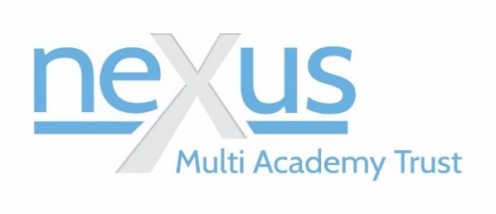

“Learning together, to be the best we can be”

# Intent

* 1. The intent of our Careers Curriculum at Coppice School is to provide a stable careers programme where all our young people are provided with the opportunity to prepare for the world of work. We intend to raise their aspirations, improve social mobility, develop 8 employability skills and enhance knowledge of labour market information whilst providing them with the right support to access the different options to help them move into paid employment. Students will experience a range of encounters tailored to their individual needs and circumstances which will include encounter of workplaces, and employers, an insight into further education establishments and opportunities for personal guidance.
  2. Coppice School has a statutory duty to adhere to the Careers Guidance and access for education and training providers: Statutory guidance for governing bodies, school leaders and school staff; use the Gatsby Benchmarks to develop and improve our careers provision; enable a range of education providers to speak to pupils in Years 8 to 13; ensure all pupils receive unbiased information about potential next steps and high-quality careers guidance; provide good quality, meaningful opportunities for pupils to encounter the world of work; enable students to make progress and move on to a higher level of qualification, employment or further education when they are ready to do so. Our sixth form prepares our students for future success in education, employment or training.

# Statutory Requirements

2.1. This policy is based on the Department for Education’s (DfE’s) statutory Careers guidance and access for education and training providers. This guidance refers to:

* The Education Act 1997
* The Education and Skills Act 2008
* The School Information (*England) Regulations 2008

2.2. This policy is also in line with the more recent Education (Careers Guidance in Schools) Act 2022. This came into force on 1 September 2022, and amended the existing duty in The Education Act 1997, so that:

2.3. Our school must now secure independent careers guidance from year 7 (instead of from year 8, previously)

2.4. As an academy in England, we’re now required to provide and publish careers guidance

2.5. The above guidance requires that schools publish information about their careers programme on their website. This policy includes this information and shows how our school complies with this requirement. Page 3 of 5 We also act in line with our statutory duty under the ‘Baker Clause’, to be impartial and not show bias towards any route, be that academic or technical. This policy should be read in conjunction with our provider access policy statement, which sets out how our school meets this duty, and can be found on our school website.

# Roles and responsibilities

3.1. Our careers leader is Chris Medwell, who can be contacted on01302 844882 or emailing cmedwell@nexusmat.org.

3.2. Our careers leader works with the Senior Leadership Team and will:

* Take responsibility for developing, running and reporting on the school’s career programme
* Plan and manage careers activities
* Manage the budget for the careers programme
* Support teachers to build careers education and guidance into subjects across the curriculum
* Work closely with the relevant staff, careers adviser, to identify the guidance needs of all of our pupils with SEND and put in place personalised support and transition plans
* Work with our school's designated teacher for looked-after children (LAC) and previously LAC to:
* Make sure they know which pupils are in care or are care leavers
* Understand their additional support needs
* Make sure that, for LAC, their personal education plan can help inform careers advice

3.3. Senior Leadership Team Our senior leadership team (SLT) will:

* Support the careers programme
* Support the careers leader in developing their strategic careers plan
* Make sure our school’s careers leader is allocated sufficient time, and has the appropriate training, to perform their duties to a high standard
* Allow training providers access to talk to pupils in years 7 to 13 about technical education qualifications and apprenticeships, and set out arrangements for this in our school’s provider access policy statement
* Network with employers, education and training providers, and other career organisations

# Careers Programme

4.1. Our school has completed a self-assessment using the Compass tool against the benchmarks and our school’s careers programme ensures that we will achieve all 8 of the Gatsby Benchmarks.

Delivery of a stable careers programme

* + - Our school careers programme is available on our school website, together with the name and contact details of our Careers Leader.
    - We have an embedded programme of careers education and guidance that is known and understood by pupils, parents, teachers, governors and employers.
    - Our school’s careers programme is monitored, reviewed, evaluated and improved by our career leader, Chris Medwell on a termly basis.
    - Our school uses the Government destinations and outcomes data to help our students compare opportunities and make informed decisions on education, training and employment options.
    - Our careers leader tracks the long-term outcomes of school leavers for a 3 year period, to inform and improve new long-term outcomes being set.

# Learning From Career And Labour Market Information

5.1. Every student and their parents have access to good quality information about future study options and labour market opportunities.

5.2. All our students and their parents have the support of an informed and impartial careers adviser to make the best use of available information.

# Addressing The Needs Of Each Pupil

6.1. Our school ensures:

* that our students EHC plans and their annual reviews include a focus on adulthood, including FE/Employment from the earliest opportunity.
* careers guidance focuses on the student’s career aspirations, and the post-16 options which are most likely to give the students a pathway into employment, further education, and provide them with the support they need to progress and succeed.
* All our students have different career guidance needs at different stages and opportunities for advice and support is tailored to meet the needs of each student.
* Our school’s careers programme embeds equality and diversity considerations throughout.
* Our school keeps comprehensive and accurate records to support the career and enterprise development of all our students.
* Our school works with the Department for Work and Pensions under their ‘Step Up’ programme for all of our students that are disadvantaged in the labour market.
* All our 16-19 students and parents are made aware of the **16-19 Bursary Fund** which is available to support vulnerable groups.

# Linking Curriculum Learning To Careers

7.1. All our students are working towards the learning outcomes as referenced within the Career Development Institute’s framework.

7.2. All our teachers link curriculum learning with careers for developing the knowledge and skills that employers need.

7.3. Our school delivers careers, employability and enterprise lessons through the curriculum as part of our commitment to Personal, Social, Health and Economic (PHSE) education.

7.4. Our school ensures that students work towards the core academic subjects English and Maths at an appropriate level to provide a broad general knowledge that will enable our students to participate in and contribute to society.

7.5. Our school ensures that students have access to The Prince’s Trust Achieve programme which promotes a flexible approach, using relevant, experiential learning to support young people to achieve a range of personal and employability skills and gain qualifications. Students also access accreditation through Open Awards, this includes a qualification in Skills for Further Learning and Employment.

7.6. STEM learning activities are included for a wide range of future career paths.

7.7. Our school is aware of the T-Levels implementation in 2019-2020 for the 15 pathways and keeps students, parents and teachers informed.

Encounters With Employers And Employees

7.8. Our school works with the Careers and Enterprise Company to implement benchmark 5 – Encounters with Employers and Employees and we have an allocated Enterprise Adviser.

7.9. Where appropriate students aged 7-13 have at least 7 encounters with employers during their education, with a least 1 encounter per year with employers from age 7- 19, which includes careers talks, careers carousels, careers fairs, transitions skills workshops, employer delivered employability workshops and business games and enterprise challenge competitions.

7.10. All our students have multiple opportunities to learn from employers about work, employment and the skills that are valued in the workplace.

7.11. Enrichment activities include visiting speakers, mentoring and enterprise schemes.

7.12. Our school ensures that micro-enterprise with local employers and businesses and professional networks is included within the careers programme to help our students gain the confidence to compete in the labour market by providing opportunities to gain he practical know-how and attributes that are relevant for employment.

7.13. Our school takes an active part in the annual Doncaster and National Careers Week and ensure that visiting speakers include quite junior employees, or apprentices, particularly alumni, with whom our students can readily identify.

# Experience Of Workplaces

8.1. All our students have first-hand experience of the workplace through work visits, work shadowing and/or work experience to help their exploration of career opportunities, and expand their networks.

# Encounters With Further And Higher Education

9.1. All our students understand the full range of learning opportunities that are available to them, including both academic and vocational routes and learning in schools, colleges, the community and in the workplace.

9.2. Providers of technical education, including apprenticeships will be invited into school to talk to year 8 to 13 students about the courses and jobs they offer.

# Personal Guidance

10.1. All our students by the age of 14 have accessed and used information about career paths and the labour market to inform their decisions on study options.

10.2. All our students have opportunities for guidance interviews with our internal Careers Lead, Chris Medwell, Planned Level 6 Careers Adviser guidance interviews are held at Yr6, Yr9, Yr11 and 13 when significant study or career choices are being made.

10.3. They will also have impartial careers advice and guidance delivered 1:1 and in small groups through Sarah Richardson, Nexus Careers Adviser. Sarah will produce a Career Action Plan which will inform discussions during Annual Reviews of student’s EHCPs

10.4. All our students have open access to personal guidance throughout the academic year.

# Strategic Objectives

**Objective 1**: ‘We will’ ensure that every child and young person builds essential employability skills from the earliest years.

**Why?** Our children and young people need to have the ability to creatively solve problems, to manage themselves, to communicate effectively and to work well with others.

## What next?

* We will have a consistent focus on the essential life skills to ensure everyone’s shared understanding and make the building of these skills as tangible as possible.
* We will start as young as possible to allow more time for mastery.
* We will take time to reflect on the skills of students, by observing or by self- assessment, identify strengths and weaknesses, highlight progress and plan for next steps.
* We will build upon a student’s previous learning and skill attainment and allow dedicated time just to explicitly build the skill.
* We will accelerate progress in the essential life skills, through providing opportunities for use and reinforcement as often as possible.
* We will ensure students see the relevance of these life skills by linking them with the real world and by bringing real-life problems and challenges to work on.

**Objective 2**: ‘We will’ ensure that every child and young person is prepared for a successful transition into further education and/or paid employment as appropriate to each student’s ability and aspirations.

**Why?** Our children and young people need to build a real life.

## What next?

* We will raise aspirations and expectations for moving into paid employment for our students as they move into adulthood.
* We will make sure that everybody knows how to support our young people to achieve life outcome for FE/Employment and work together to deliver an outstanding SEND provision.

**Objective 3**: ‘We will’ ensure that we have a structured Post-16 study programme working with local businesses and community groups to help our young people be prepared for life after Coppice School as appropriate to each student’s ability and aspirations.

**Why?** Our young people need the right opportunities, preparation and support to move into paid employment.

## What next?

* We will make sure that our young people and the adults who support them know what choices are available.
* We will make sure that everyone is thinking about the best way to prepare our young people for paid work, based on their career hopes and qualifications.
* We will make sure our young people have access to a full-time education study programme which includes a experiences of work
* We will make sure that we build continuity partnerships with the external provision who have particular expertise in supporting our young people as they move into paid employment (study programmes, supported internships, traineeships, apprenticeships, access to work and routes into work).

# Monitoring & Evaluation Plan

12.1. The careers programme at Coppice School is delivered through a variety of activities including; timetabled lessons, in line with the Careers Programme, within curriculum areas as well as bespoke opportunities, activities and events ran by external agencies, businesses and employers.

12.2. By having a structured programme of events, monitoring and evaluation allows us to ensure the quality of our provision and inform our future decision making.

12.3. Monitoring activities adopted by Coppice School are:

* Learning walks
* Lesson observation
* Key stakeholder voice meaningful encounter feedback - students, staff, parents & carers, external agencies
* Whole school careers tracking
* Internal moderation – work products, qualifications/accreditation, EHCP documents

12.4. Evaluation activities are used to measure the impact of our careers programme and inform planning of future events.

12.5. Evaluation activities adopted by Coppice School are:

* Analysis of whole school careers tracking
* Feedback from personal guidance interviews
* Lesson observations
* External moderation – qualifications/accreditation
* Key stakeholder voice careers programme evaluation - students, staff, parents & carers, external agencies
* Termly and Annual Careers Programme Evaluation Review Meetings with School Enterprise Adviser and Enterprise Co-ordinator
* Destination data

12.6. Each academic year the Careers Leader following the Annual Review of the Careers programme, will update the Action Plan and the provision on offer to students will be audited utilising the Compass Plus tool.