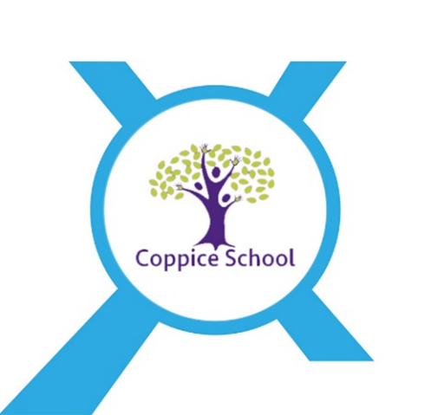

Our Careers Strategy and Programme

The intent of our Careers Strategy at Coppice School is to provide a stable careers programme where all our students are provided with the opportunity to prepare for their transition into the world of work. We intend to break down barriers, raise their aspirations, improve social mobility, develop the 8 employability skills and enhance knowledge of labour market information whilst providing them with the right support to access the different options to help them move into paid employment. Students will experience a range of encounters tailored to their individual needs and circumstances which will include encounter of workplaces, and employers, an insight into further education establishments and opportunities for personal guidance.

Whole School Vision
“To allow all children and young people to hold their rightful place in society, equipped with the knowledge, skills and voices to make a positive contribution to the world.”

Nexus Multi-Academy Trust Vision for Careers Provision
Coppice School is a Nexus academy and Nexus Multi-Academy Trust supports every pupil to realise and develop high aspirations and consider a broad and ambitious range of careers through a combination of direct/indirect experiences and learning opportunities in line with the Nexus Careers Education (inc. Provider Access) Policy.
At Nexus the Multi-Academy vision is that we are constantly “Learning together; to be the best we can be.”

Coppice School CEIAG Strategic Action Plan 2020-2023

Strategic Objectives
Objective 1: ‘We will’ ensure that every child and young person builds essential employability/life skills from the earliest years.
Why? Our children and young people need to have the ability to creatively solve problems, to manage themselves, to communicate effectively and to work well with others.
What next?
- We will have a consistent focus on the essential life skills to ensure everyone’s shared understanding and make the building of these skills as tangible as possible.
- We will start as young as possible to allow more time for mastery.
- We will take time to reflect on the skills of students, by observing or by self-assessment, identify strengths and weaknesses, highlight progress and plan for next steps.
- We will build upon a student’s previous learning and skill attainment and allow dedicated time just to explicitly build the skill.
- We will accelerate progress in the essential life skills, through providing opportunities for use and reinforcement as often as possible.
- We will ensure students see the relevance of these life skills by linking them with the real world and by bringing real-life problems and challenges to work on.

Objective 2: ‘We will’ ensure that every child and young person is prepared for a successful transition into further education and/or paid employment as appropriate to each student’s ability and aspirations.
Why? Our children and young people need to build a real life.

What next?

- We will raise aspirations and expectations for moving into paid employment for our students as they move into adulthood.
- We will make sure that everybody knows how to support our young people to achieve life outcome for FE/Employment and work together to deliver an outstanding SEND provision.

Objective 3: ‘We will’ ensure that we have a structured Post-16 study programme based primarily at an employer to help our young people move into paid employment as appropriate to each student’s ability and aspirations.

Why? Our young people need the right opportunities, preparation and support to move into paid employment.

What next?

- We will make sure that our young people and the adults who support them know what choices are available.
- We will make sure that everyone is thinking about the best way to prepare our young people for paid work, based on their career hopes and qualifications.
- We will make sure our young people have access to a full time education study programme which includes a supported internship or traineeship.
- We will make sure that we build continuity partnerships with the external provision who have particular expertise in supporting our young people as they move into paid employment (study programmes, supported internships, traineeships, apprenticeships, access to work and routes into work).

The National Careers Strategy and Young People with SEND
The National Careers Strategy makes it very clear that ALL young people including those with SEND are to be supported to achieve their optimum career outcome. For young people with SEND, the activities should be differentiated using our professional judgement as we would do in every activity we plan for our students.

Our school ensures that we:
- Consider the widest range of possible career options;
- Raise aspirations of students, their families and staff to start from the presumption of paid work;
- Help parents/families engage more;
- Increase authentic and meaningful employer encounters;
- Differentiate careers activities as appropriate;
- Improve career development for the most vulnerable;
- Use 16-19 bursaries if possible (or 19+ for those with an EHC Plan);
- Facilitate career decisions based on a young person’s aspirations, abilities and needs;
- Ensure careers (personal) guidance is differentiated and Careers Advisers’ skills are developed;
- Named Careers Advisers are encouraged to build longer term relationships with students and use EHC Plans as a lever.

Our Careers Leader has key aspects to their role when it comes to our young people with SEND including:
- Destination tracking and improving destinations through an increasingly effective programme and understanding more about potential destinations;
- Managing the delivery of careers guidance and the development of an effective careers guidance delivery plan for ALL students;
- Employer liaison that requires more preparation of and support for the employer;
- Working closely with teachers/tutors;
- Greater emphasis on engaging with families;
- Liaising with more outside agencies potentially;
- Positive Career Outcomes for our Career SEND Group 1 – although our students do not take Level 2 Qualifications/GCSEs, they do have high aspirations to enjoy career outcomes including supported employment, supported internships, inclusive apprenticeships, supported enterprise, t-levels, traineeships and further education college.
The SEND Gatsby Benchmarks:
 | Benchmark | What to expect
1 | Careers Programme | Careers Activities like special lessons, meeting employers, work experience and making plans.
2 | Careers Information | Finding out about jobs and training opportunities and what they might like.
3 | Career Plan | Making plans for what they want to do when they leave school.
4 | Careers Lessons | Careers lessons in their classroom and learning work related skills.
5 | Meeting Employers | Meeting employers at school and in the workplace.
6 | Work experience | Practising working and work skills in the Employers workplace.
7 | Visits | Visits to College, employers and potential Supported Internship and Apprenticeships.
8 | Careers Guidance | Meeting with a Careers Adviser with their family and teachers to discuss their career plans.

The CDI (Career Development Institute) Career Development Framework
The main purpose of the CDI’s Career Development Framework is to clarify the skills, knowledge and attitudes that individuals need to have a positive career. A ‘positive career’ will mean something different to everyone, but it will typically include being happy with the way you spend your time, being able to make a contribution to your community and being able to have a decent standard of living.

Our school ensure that we:
- Use the framework to support the development of our careers programme across all key stages.
- Increase effectiveness by using it alongside our strategic careers plan.
- Use the framework to support a progressive framework that enables our Careers Leader to think about the outcomes they are hoping to achieve for our young people.

The CDI Career Development Framework – Primary, KS3, KS4 and Post 16:
Grow throughout life | Grow throughout life by learning and reflecting on yourself, your background and your strengths.
Explore possibilities | Explore the full range of possibilities open to you and learn about recruitment processes and the culture of different workplaces.
Manage career | Manage your career actively, make the most of opportunities and learn from setbacks.
Create opportunities | Create opportunities by being proactive and building positive relationships with others.
Balance life and work | Balance your life as a worker and/or entrepreneur with your wellbeing, other interests and your involvement with your family and community.
See the big picture | See the big picture by paying attention to how the economy, politics and society connect with your own life and career.

The Skills Builder Universal Framework for Essential Skills
The Skills Builder Universal Framework shows how to build essential skills at every stage of life.
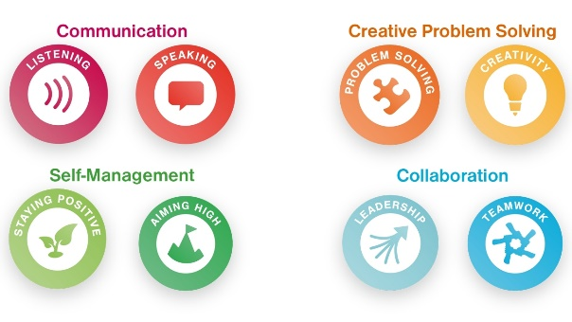
This Framework is used to support our children and young people to:
- Understand their existing skills: Reflecting on where their essential skills currently are, and being able to identify any gaps they might have
- See what progress looks like: Being able to see what the next steps are to improve their essential skills further
- Join the dots: Using a consistent language and understanding of essential skills to understand how they are used and practiced in lots of different settings
- Capturing success: Seeing progress and being able to better articulate their skills
Our school has an annual subscription to Skills Builder’s online tools and resources. This joins up teachers under one account, unlocks resources for Challenge Days and Extended Projects, and measures student progress in eight essential skills.
Careers Programme

Our Careers Programme helps students to:
- Find out about different jobs
- Think about what they could do after they leave school
- Learn about the skills they need for working
- Record the skills they have learnt
- Make a career plan with other’s help
- Talk to their family about what they would like to do

Our Careers Programme Partner:
- Careers at EVERY Level
Our school works with Talentino! to provide a meaningful Careers Development Programme.
Talentino! is an award - winning independent early career development organisation that focuses on enabling young people to become career ready. They are the strategic partner for SEND for the Careers and Enterprise Company.

How do we work with Talentino?
Nobody knows our students better than us, so Talentino! has created a ‘Careers at EVERY Level Digital resource guide’, which can be tailored to the individual needs of our students. The guide gives us a brief description of each resource, as well as the link to them and a suite of training videos for training staff.

What are the aims of our Careers Programme?
The aims of the programme are to improve the possibility and probability of paid work; to improve work related skills for independent living and supported employment and enrich life experience.

Our students Careers at EVERY Level Career Development Plan
This forms the ‘Careers Story’ for our students and enables students to get involved and own their own career development. It highlights the process through which they will progress, with a clear and simple tracking process, of getting ready for their career, and what steps they can take to realise their aspirations. Each stage of their Early Career Development can be marked with a series of ‘emojis’, which mark their progress, and can help us as a career coach establish where extra development is required.
Contents include:
- Opportunities for when they leave school
When they leave school at 16 or 18 or 19, there are different types of opportunities that could be available locally including:
Opportunity | What will they do?
Paid job / supported employment | Work for an employer for money with support to be able to do their job well if they need it.
Supported Internship | With an EHC Plan, they can train for work with an employer and carry on studying at the same time for a minimum of 6 months. This can lead to a paid job.
Supported / inclusive Apprenticeship | Carry on studying after school at their local College. There are different courses they can choose.
Enterprise / supported Enterprise | If they have an idea for a business, they can sell their goods or services with support from a responsible adult and earn money.
Working for yourself | They could work for a small business on a self-employed basis which can be a more flexible way to work and earn money.
Extended work placement | This is like work experience, but they would do it for a longer time to gain more experience.
Supported Volunteering | Volunteer for part time work in a charity where they will be supported.

- The development – getting ready for their career
Careers lessons:
Career Coaching Curriculum
- What is work?
- What sort of help do I need to ask for?
- What should I choose?
- I am ready for work!
- How do I get a job?

- Meeting employers
Activities:
- Work experience
- Employer visits
- Enterprise
- Working in a part time job

- Rehearsing for working
Activities:
- Before they go to work
- When they are at work
- Travel training
- Preparing a CV
- Completing an Application Form
- Developing Interview skills

- Learning work related skills
Job Family:
- Personal Grooming
- Personal Care
- Food and Catering
- Household Tasks
- Gardening
- Office
- Recycling
- Practical Support Tasks
- Cleaning
- Looking after animals

- Learning employability skills
Personal skills:
- Staying positive
- Being confident
- Being determined
- Enjoying learning
- Managing self
- Being aware of others’ feelings
- Self-regulating
- Being motivated
Skills for working:
- Staying safe online
- Using a computer
- Using email
- Using Word
- Enjoying coding
- Enjoying serving customers
- Using their initiative and making things happen
- Being aware of the time

Skills at work:
- Solving problems
- Talking to people politely
- Making notes
- Organising
- Making suggestions
- Helping to make things better
- Answering the phone
- Making a call on the phone

- Getting ready for their next steps
Activities:
- Exploring Jobs they could do
- Finding out about jobs and training opportunities
- Visiting Colleges

- Making plans by exploring
Activities:
- What they want to do
- Meeting the Careers Adviser
- Exploring options with their family
- Meeting Job Coaches
- Finding out what other students have done

- Exploring with their teacher/tutor what they would like to do more of
Activities:
- Learning more about working
- Learning more about training like Supported Internships and Inclusive Apprenticeships
- Meeting more employers
- Doing more work experience
- Learning more about work-related skills
- Doing more Enterprise
- Doing more planning

Termly review and evaluation of our Careers Programme
The Careers Programme is delivered through a variety of activities including; timetabled lessons, within other core curriculum areas as well as bespoke opportunities, activities and events ran by external agencies, businesses and employers.
Our Careers Leader monitors delivery on a termly basis. The activities delivered are reviewed against the SEND Gatsby Benchmark and CDI Careers Development Frameworks. Following this our Careers Leader completes a COMPASS+ Careers Benchmark Tool Evaluation and reports to the Senior Leadership Team, Link Governor for Careers and the Nexus Multi-Academy Strategic Lead with details of any actions that are required to ensure our Careers Programme meets our students needs and also meets with the statutory requirements throughout the current academic year.

