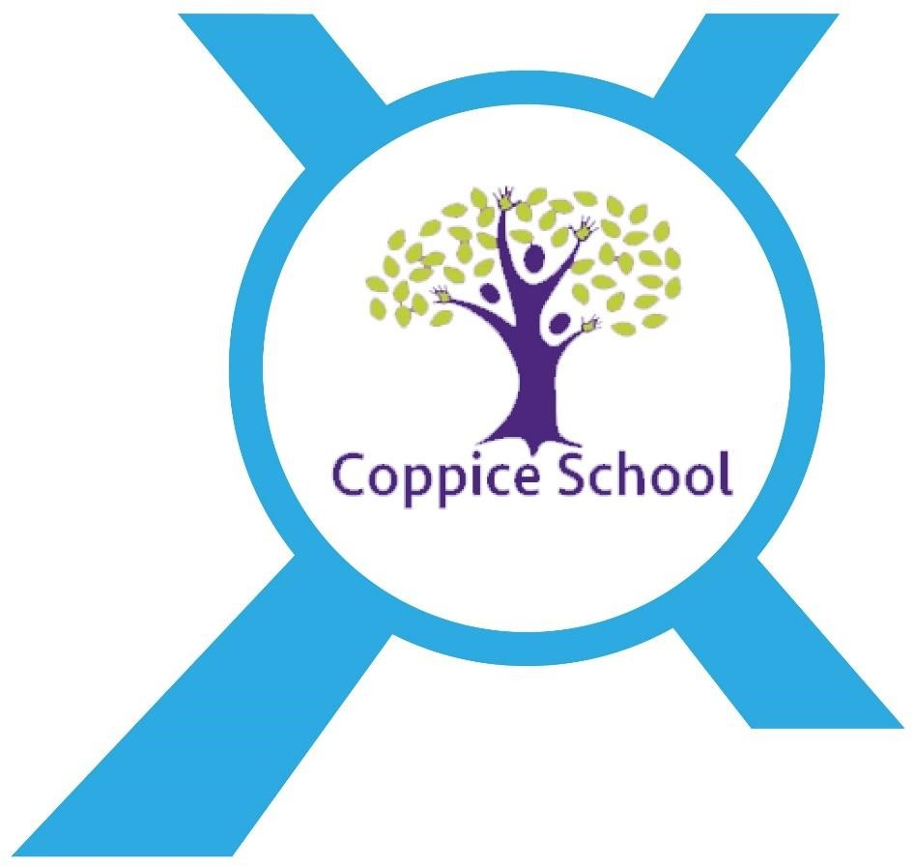

Provider Access Policy

Last reviewed on: | September 2025
Next review due by: | September 2026

An academy within:
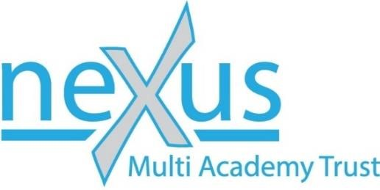

“Learning together, to be the best we can be”

Coppice School: Provider Access Policy Statement
(To include The Department of Education, July 2021: “Baker Clause” and the Provider Access Legislation, January 2023)
Ownership: Coppice School, Nexus MAT
Date updated: September 2025

Rationale
High quality careers education and guidance in school or college is critical to a young person’s future. It helps to prepare them for the workplace by providing a clear understanding of the world of work and next steps including the routes to jobs, careers that they might find engaging and rewarding along with transitions into social care. It supports them to acquire the self-development and career management skills they need to achieve positive employment destinations. This helps students to choose their pathways, improve their life opportunities and contribute to a productive and successful economy.
As the number of apprenticeships rises every year, it becomes increasingly important that all young people have a full understanding of all the options available to them Post-16 and Post-18 including wider technical education options such as T-Levels and Higher Technical Qualifications.

Commitment
Coppice School is committed to ensuring that careers are person centred and allows for all students to have a successful transition for their journey after Coppice School.
As a school we know that employment will not be the next steps for all of our students so we endeavour to offer them information relating to next steps including social care provisions.
Coppice School is fully aware of the responsibility to set students on the path that will secure them the best outcome which will enable them to progress in education and work and give employers the highly skilled people they need. That means acting impartially, in line with the statutory duty, and not showing bias towards any route, be that academic or technical.
As a school we endeavour to ensure that all students where appropriate are aware of all next steps including routes to higher skills they are able to access information on technical options and apprenticeships. (The Department of Education, July 2021: “Baker Clause”: supporting students to understand the full range of education and training options, and the Provider Access Legislation, January 2023).

Aims
Coppice school policy for Access to other education and training providers has the following aims:

- To support young people to develop the knowledge and awareness of all career pathways available to the, including technical qualifications and apprenticeships.

- To support young people to be able to learn more about the opportunities for education and training outside of school before making crucial choices about their future options.
- To reduce drop out from courses and avoid the risk of students becoming NEET (Young people not in education, employment or training).

Student Entitlement
Coppice school fully supports the statutory requirement for students to have direct access to other providers of further education training, technical training and apprenticeships. The school will comply with the new legal requirement to put on at least six encounters with providers of approved technical education qualifications or apprenticeships where appropriate. This will be done through assemblies, lessons and National Careers Week. Students will also attend careers events at school and in the local community.
All students in years 7-14 are entitled:
- to two encounters in Year 8 or 9 that are mandatory for all students where appropriate to attend;
- to two encounters in Year 10 or 11 that are mandatory for all students where appropriate to attend;
- to be given the opportunity to find out about technical education qualifications and apprenticeship opportunities;
- to hear from a range of local providers about the opportunities they offer, including technical education and apprenticeships;
- to develop the skills needed to make applications, interview, through lessons, 1:1 session with the careers advisor.
Development
This policy has been developed and is reviewed annually by the Careers Leader and Line Manager based on current good practice guidelines by the Department for Education.
Links with other policies
It supports and is underpinned by key school policies including those for Careers, Child Protection, Equality and Diversity, and SEND. Skills and Post 16 Education ACT 2022
Equality and Diversity
Access to other providers is available and promoted to allow all students to access information about other providers of further education and apprenticeships. Coppice School is committed to encouraging all students to make decisions about their future based on impartial information.
Requests for access
Requests for access should be directed to Annabelle Peacock, Careers Leader. Annabelle can be contacted by email at apeacock@nexusmat.org or telephone, 01302 844883.

Grounds for granting requests for access
Access will be given for providers to attend during school assemblies, timetabled Careers lessons, and Careers or Raising Aspirations events that Coppice School arrange. Students may also travel to visit another provider as part of the trip to be organised in partnership with Coppice and the wider Nexus trust.
Details of premises or facilities to be provided to a person who is given access
Coppice School will provide an appropriate room or hall to be agreed. The Careers Leader or Careers Advisor will organise this, working closely with the provider to ensure the facilities are appropriate to the audience. Appropriate safeguarding checks will be carried out. Providers will be met and supervised by a member of the Careers Team who will facilitate.
Live/Virtual encounters
Coppice School will consider live online encounters with providers where requested, and these may be broadcast into classrooms or the school assembly hall.
Parents and Carers
Parental involvement is encouraged, and parents may be invited to attend the events to meet the providers. Throughout the year events will be held to allow for families to come on site to meet with further education providers.
Management
The Careers Leader/ advisor coordinates all provider requests and is responsible to his/her senior management line manager.
Complaints Procedure
Any complaints about this policy should be raised to via the school complaints procedures- please see policy for further details.

Monitoring review and evaluation
The Policy is monitored and evaluated annually via the Executive Leadership Team.

Policy Reviewed: September 2025

Appendix
Providers who have been invited into Coppice School to date include:
Doncaster Communication Specialist College
Landmarks College
Doncaster College
Inspired Day Care
Diamond Centre
SMILE Centre

Destinations of previous pupils from Coppice School include:
Doncaster Communication Specialist College
Landmarks College- Rotherham
Doncaster College
The Ridge Employability College (TREC)
Inspired Day Care
Apprenticeship – Owston Hall

