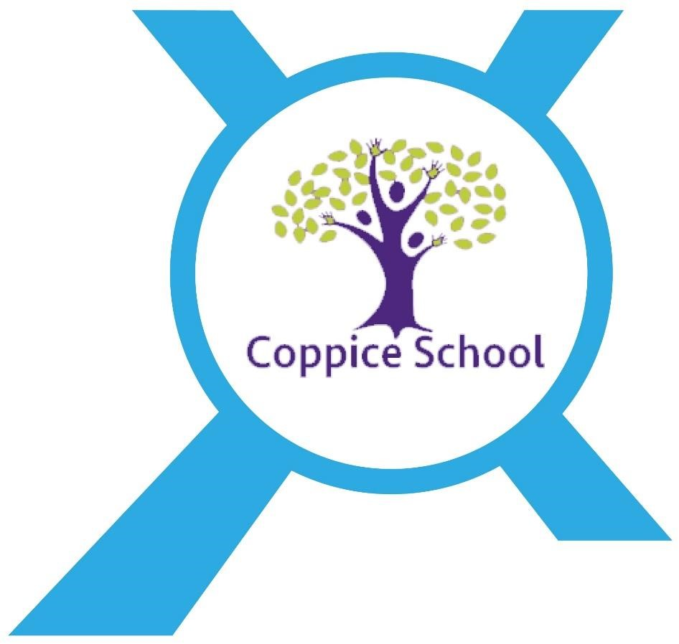

Provider Access Policy

Last reviewed on: | January 2024
Next review due by: | September 2024

An academy within:
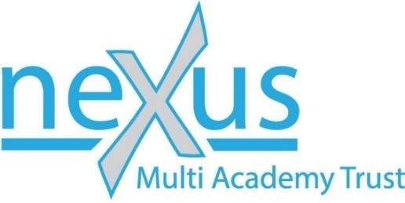

“Learning together, to be the best we can be”

Introduction:

This policy statement sets out the school’s arrangements for managing the access of providers to the school for the purpose of giving them information about the provider’s education or training offer. This complies with the school’s legal obligations under Section 42B of the Education Act 1997.

This policy statement sets out the school’s arrangements for managing the access of providers and services to learners at our school for the purpose of giving them information about the Doncaster Local Offer - SEND. This complies with the school’s legal obligation under ‘The Education (Careers Guidance in Schools) Act 2022.

This policy statement also sets out the school’s arrangements for ensuring learners receive independent careers guidance from year 7, where their interests, life and employability skills, learning steps, job choices and next steps students are discussed and a Careers Action Plan produced. The independent careers guidance meeting will be an introduction to the Doncaster Local Offer - SEND in relation to their Life After Coppice Exit Routes Options.

Coppice school has a responsibility to ensure learners secure the best outcome to help them progress into meaningful social and/or further education and work. Our school acts impartially and does not show bias towards any route, be that social, academic, vocational or technical.

Our school opens it’s doors to other Doncaster Local Offer - SEND social, life and education providers and we ensure that our learners are aware of the benefits of supported internships, traineeships, apprenticeships, supported employment, paid employment, volunteering and other vocational or technical education qualifications, so that our students can consider them, alongside academic options, when making choices about their future.

Pupil entitlement:

Our school supports all learners through providing opportunities for visits from a range of providers for Key Stage 3, 4, Post-16 and Post-19 options, as appropriate to their needs through:

- Providing a minimum of six encounters with a provider of vocational, technical education or supported internships, traineeships or apprenticeships for our Year 8 to 14 pupils:

  - Holding a ‘Preparing for adulthood – Pathways Event’ during Spring Terms and inviting the Doncaster Local Offer - SEND education and services providers into school to meet with our students, parents and carers.

Providers are asked to provide information to pupils, parents and carers, as a minimum, to include:

    - Information about the provider and the approved life, education and/or vocational, technical qualifications or routes into work that the provider offers.
    - Information about the careers to which those education, vocational and technical or routes into work might lead.
    - A description of what learning and training with the provider is like.
    - A response to questions from pupils, parents and carers about the provider or the approved life, education and or vocational, technical qualifications and routes into work.

  - Carrying out planned ‘External Education and Service Provider Environment Visits’ during Summer Terms to look at environments, meet staff and talk to alumni and/or other attending students.

  - Holding option events, assemblies, careers talks, taster events and making applications workshops during Autumn Terms.

Meaningful provider encounters

One encounter is defined as one meeting/session between pupils and one provider. We are committed to providing meaningful encounters to all pupils using the Making it meaningful checklist. 1540_Make it meaningful checklist_v6 (FINAL).pdf (careersandenterprise.co.uk)

Meaningful online engagement is also an option, and we are open to providers that are able to provide live online engagement with our pupils.

Previous providers and services

Doncaster College
Dearne Valley College
Barnsley College
Landmarks
Communication Specialist College
Harrison College
The Ridge Employability College
SMILE Day Opportunity Services

Destinations of our pupils 2021-2022

Communication Specialist College
The Ridge Employability College
SMILE Day Opportunity Services

Destinations of our pupils 2022-2023

Doncaster College
Dearne Valley College
The Ridge Employability College

Management of provider access requests:

A provider wishing to request access should contact Chris Medwell, Careers Leader on:

Telephone: 01302 844883
Email: cmedwell@nexusmat.org

Premises and facilities:

The school will make the main hall, classrooms or private meeting rooms available for discussions between the provider and students, as appropriate to the activity. The school will also make available AV and other specialist equipment to support provider presentations. This will all be discussed and agreed in advance of the visit with the Careers Leader.
Providers are welcome to leave copies of their prospectus or other relevant course literature for the Doncaster Local Offer - SEND information display, which is maintained by the Careers Lead and available to students, parents and carers.

Details of premises/facilities to be provided to a person who is given access:

Access to our premises/facilities will be considered on an individual basis and in line with our Whole School Policy for Safeguarding, Incorporating Child Protection.

Grounds for granting and refusing requests for access:

Granting: Provision is a realistic exit route for our students.
Refusing: Provision is an unrealistic exit route for our students.
Complaints

A provider wishing to make a complaint should contact Miss Natalie Swearman, Headteacher on:

Telephone: 01302 844883
Email: nswearman@nexusmat.org

A copy of our complaints procedure can be found on the school website.

Complaints can also be made directly with The Careers & Enterprise Company via provideraccess@careersandenterprise.co.uk

Update and review

Information updated January 2023 by Ms Tracey Senior, Careers Leader in line with statutory guidance released on 05/01/23.

Further updated January 2024 by Chris Medwell, Careers Leader.

