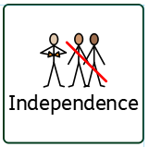
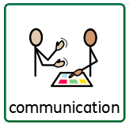
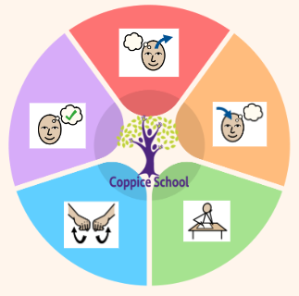
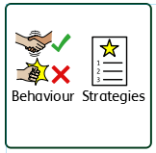
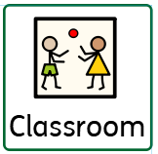
Composite Half Termly End Point:
Yellow: Moves a car along a road map. Is able to move around school with support. Can make a choice about their destination.
Blue: Discusses familiar routes.
Begins to draw/mark make to identify a route or design. Moves around the building confidently and safely*.
Green: Begins to follow road safety instructions. Knows directions to get around local places*. Follows direction around class and school.
Composite Half Termly End Point:
Yellow: Make simple structures with adult support. Begin to connect construction kits together.
Blue: Construct with a purpose in mind, using a variety of resources (e.g. make a representation of event, person or object.) Show confidence in using construction kits including some complex actions (e.g. wheels.)
Green: Communicate about how their products will look, how they are making it and their finished product using either words, symbols, drawing or labels. Follow a simple plan. Explore mechanisms [for example, levers, sliders, wheels and axles].
DT
Composite Half Termly End Point:
Yellow: Shows empathy by offering comfort item/activity that they themselves would find soothing, i.e. their toy
Blue: Show kindness by comforting others with words or actions they think the other person would like e.g. bringing them their bag/coat.
Composite Half Termly End Point:
Yellow: Take on small responsibilities that help the class or community (e.g., watering plants, handing out cups)
Blue: Identify some simple ways in which we can take care of people / animals / the environment. Show pride in helping others
To support pupils to develop independence we encourage…
Opportunities for independence throughout the day, tidy up, snack time, choice boards, pupil voice, changing, toileting.
Composite Half Termly End Point:
Yellow: Share new experiences with familiar adults.
Blue: Understand what is meant by family and communicate about my home and family.
Green: Identify the people who love and care for me and how they help me feel cared for.
Geography
Maths
Science
DT – My Cooking
Composite Half Termly End Point:
Yellow:
Follow instructions and prompts to turn on the tap. Follow instructions and prompts to rub my hands with soap.
Follow instructions and prompts to put my hands under water to rinse them.
Put on my apron with adult prompts and support. Explore mixing with physical support.
Explore pouring with physical support.
Blue:
Follow instructions to turn on the tap.
Follow instructions to rub my hands with soap. Independently follow instructions to wash my hands.
Find my apron and put it on independently.
Mix ingredients independently.
Pour ingredients independently
Composite Half Termly End Point:
Yellow: Initiate the exploration of objects and understand what objects are used for*
Blue: Begins to comment on similarities and differences*
Green: Know some facts about the Sun, Moon and some other planets (Space).
Number Set 2
Half Termly End Point:
Yellow:
L1 Demonstrating an understanding of more/less, and zero/nothing/nil.
L2 Responding to key vocabulary such as number, how many, count, same number, more, less.

Blue:
L1 Combining two small sets and counting the total, and taking away from a number of items and counting the remainder.
L2 Combines two sets and counts the total, and subtracts from a set and counts the remainder.

Data Handling
Half Termly End Point:
Yellow:
L1 To sort objects/pictures into two sets using a given criteria, and indicate an item that is different within a given set.
Blue:
L1 To record using simple pictorial representation.
In our learning environment, displays and provision we are trying to support and facilitate the following knowledge and skills; communication, independence, perseverance, a love for learning, pride, confidence, regulation, readiness for learning, reading.
To support behaviours in our class you will see the following strategies: planned ignore, visuals, Makaton, now and next, choose boards, firm voice, countdowns, visual timers, movement breaks, motivators, reduced language.
RE

Theme:
Moving Parts
RSE

MY WORLD
To support pupils to have a voice we will use…
communication boards, PECS, Makaton, reduced language, sentence strips, communication books
Class: Hazel
Pathway: Semi-Formal
Term: Autumn 2
Changing, walking to the shop
Work first then, BLQ, purchasing snack
Sensory circuits, movement breaks
PECs, turn taking, sharing, HCS
Cognition & Learning
Social, Emotional & Mental Health
Communication & Interaction
Physical & Sensory
Overarching EHCP
Life-Long learning
Developing Independence
PSHE

Happy Centred Schools Driver
Confidence

