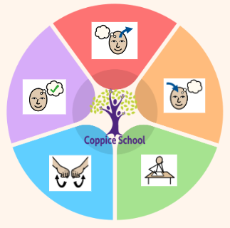
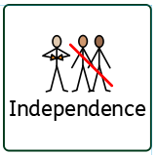
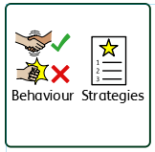
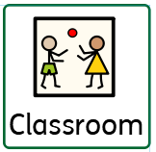
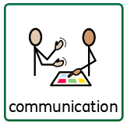
In our learning environment, displays and provision we are trying to support and facilitate the following knowledge and skills; independent child-initiated mark making, touch counting with correspondence to ten and beyond
Science
Strand: Forces

Class: Holly
Pathway: Semi-formal
Term: Autumn
DT
Strand: My Cooking

Geography
Strand: Transport

DT
Strand: Materials

ENGLISH

MATHS
- Number
- Geometry

To support pupils to develop independence we encourage…
Self-dressing, toileting, teeth brushing, hair brushing
To support behaviours in our class you will see the following strategies: Countdowns, PECs, strong routines, modelling of positive behaviours from adults
Cognition & Learning
Toilet training
Social, Emotional & Mental Health
Communication & Interaction
Physical & Sensory
Overarching EHCP
Life-Long learning
Developing Independence
PSHE
Theme:
Moving Parts!

Happy Centred Schools Driver:
Confidence

Communication Half Termly End Point:
Show a reflex response to a sudden sound. Turn towards a familiar sound.
Respond non-verbally in two-way interaction. Looks quickly towards the source of a familiar sound or voice.
Respond to a familiar adult calling my name.

Reading Half Termly End Point:
Show awareness of sensory input from a story. Make choices.
Identify familiar sounds.
Identify the sound I have heard.

Writing Half Termly End Point:
Hold something for a short time.
Use my fingers or toes to spread or rake a sensory media across a surface. Pick up small objects, developing a pincer grasp.
Point as part of communicating. Follow a route on a road map or track.
Number:
fully prompted touch objects as they are being counted
show interest in hand tapped numbers
shift visual attention by looking from one object to another.
notice changes in number of objects/images or sounds in group of up to 3.
tolerate interacting with an adult to play finger rhymes or rhythmic tapping
Pupils interacts with familiar number rhymes and songs Pupil experiences 1:1 correspondence in everyday situations Pupil touches, observes or gazes at objects one at a time as adult counts Pupil indicates which group contains one. Pupil indicates one object. Pupil indicates 2 objects.
Pupil demonstrates an understanding of 1:1 correspondence in everyday situations Pupil participates in number activities reciting numbers one to five and may use fingers to identify numbers Pupil creates sets to three Pupil counts five objects by touching one at a time, arranged in a line and randomly – including 1p coins
Geometry:
Accepts coactive exploration of objects. Tolerates sensory exploration of tactile materials with support. Explores objects of varying sizes, weights and shapes using a range of senses, e.g. looking, mouthing.
Pupil experiences 2D shapes in a range of practical situations. Pupil experiences 3D shapes in a range of practical situations Pupil can post items according to their shape by trial and error.
Pupil can match 2D and 3D shapes Pupil matches 2D shapes to their outline

Books:
Look Up – By Nathan Byron
Russell’s Christmas Magic By Rob Scotton

Composite Half Termly End Point:
Explore objects by looking, touching and mouthing. Tolerate adult interaction when exploring objects.
Explore and experiment with a range of media using whole body. Explore different materials independently, paying attention to what happens next.
Make simple structures with adult support. Begin to connect construction kits together.
Pecs Exchange
Hygiene – hand and nail washing

Composite Half Termly End Point:
Recognise a familiar route Indicate the direction of a place I wish to go to.
Recognises familiar places. Begin to move a car along a road map. Begins to make a choice about where to go.
Is able to move around the school with adult support. Can make a choice about their destination. Moves a car along a road map.

Composite Half Termly End Point:
Observe and repeat a cause and effect actions such as reacting to lights or moving toys. Show an awareness of their own body by reacting to objects of various weights, volumes, speeds, lights. Tolerate coactive explorations and experiences with an adult such as filling up, lifting, moving, turning on and off toys
Notice changes in sound, light, size, texture and movement. Explore intentionally objects with hands, including banging, dropping, squeezing. Tolerate and interact with others including accepting gentle touch, pushing and pulling objects and dropping toy
Operate mechanical toys e.g. Turning the knob on a toy or pull back a car. Understand what objects/toys are used for with an adult’s support. Initiate the exploration of objects that can be pushed/ pulled or switched on.
Blank level questioning

Composite Half Termly End Point:
Tolerate an adult washing my hands. Tolerate an adult putting on my apron Handle a range of food with assistance.
Accept hand washing as part of my routine. Accept putting on an apron as part of my routine. Explore and experiment with a range of food using my whole body.
Follow instructions and prompts to wash hands. Put on my apron with adult prompts and support. Explore mixing and pouring with physical support.

PE
Strand: Ball Skills

RE
Strand: Respect

Composite Half Termly End Point:
Recognise familiar faces and voices of significant people Show simple reflex responses to religious or spiritual images and objects.
Observes and show interest as people move around Begin to recognise and explore a variety religious and spiritual images and objects.
Take part in activities involving two or three other learners, taking notice of other people’s responses. Recognise and respond to a variety of religious and spiritual images and objects.
Composite Half Termly End Point:
Reaches out for touches and begin to hold objects. Play a simple ball game with support such as pushing a ball to a target. Turns head in response to objects with light or sound stimulus.
Drop a ball and track it when bouncing and chase a ball. Push a ball independently and receive a ball that’s is rolled towards me. Throw an such as a beanbag without direction. Roll a ball towards a target such as skittles.
Propel a ball in three different ways – such as - throw, roll, kick, push. I am beginning to negotiate space safely. I am beginning to take turns with others.

RSE
Strand: Safety and changing body
MY WORLD
Strand: Health and well being

Composite Half Termly End Point:
Calm when familiar adults using appropriate calming strategies for me. Accept help from a familiar adult.
Tolerate massage and calming touch from a familiar adult Ask for more of an activity using actions or vocal sounds.
Find or use a comfort toy or object to calm. Engage in Intensive Interaction with familiar adults for extended periods of time. Communicate ‘no’ to an adult (demonstrate sense of self as an individual.)

Composite Half Termly End Point:
Show an emotional response to physical interactions (e.g. being tickled.) Tolerate coactive involvement with an activity.
Tolerate care-giving routines (e.g. personal hygiene) Cooperate with care-giving activities (e.g. dressing.) Show some understanding of ‘yes’, ‘no’ and some boundaries.
Cooperate with and show some understanding of routines. Understand what everyday objects are used for (e.g. put a hairbrush to my head.)

To support pupils to have a voice we will use…
PECs, communication books, Makaton, choices

