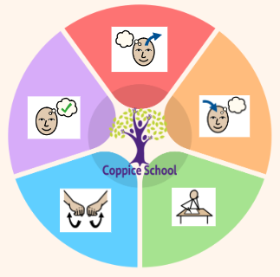
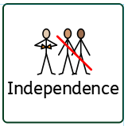
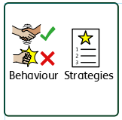
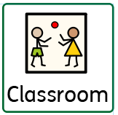
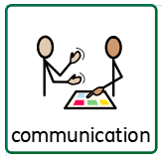
To support behaviours in our class you will see the following strategies: Countdowns, PECs, strong routines, modelling of positive behaviours from adults
In our learning environment, displays and provision we are trying to support and facilitate the following knowledge and skills; independent child-initiated mark making, touch counting with correspondence to ten and beyond
Science
Strand: Forces

Class: J6
Pathway: Semi-formal
Term: Autumn 2
DT
Strand: My Cooking

Geography
Strand: Transport

DT
Strand: Materials

ENGLISH

To support pupils to develop independence we encourage…
Self-dressing, toileting, teeth brushing, hair brushing
Cognition & Learning
Independence
Social, Emotional & Mental Health
Communication & Interaction
Physical & Sensory
Overarching EHCP
Life-Long learning
Developing Independence
PSHE
Theme:
Moving Parts!

Happy Centred Schools Driver:
Confidence

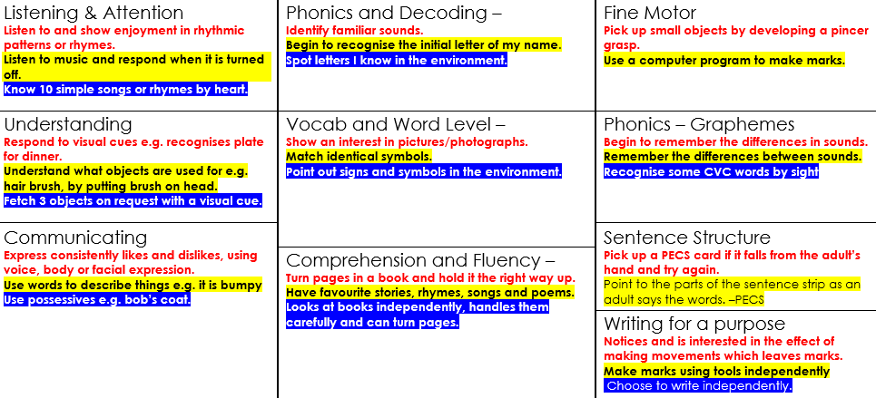
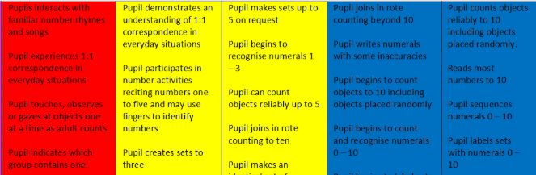

Books: · Man on the Moon - by Simon Bartram. · The Great Reindeer Rescue – Stephen Mangan.

MATHS
- Number
Data handling

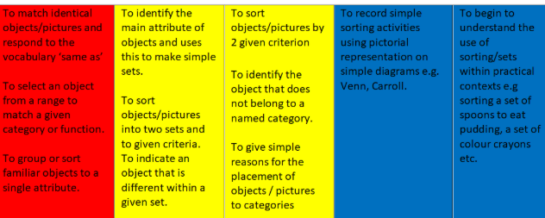

Composite Half Termly End Point:
Explore and experiment with a range of media using whole body. Explore different materials independently, paying attention to what happens next.
Make simple structures with adult support. Begin to connect construction kits together. Construct with a purpose in mind, using a variety of resources (e.g. make a representation of event, person or object.)
Show confidence in using construction kits including some complex actions (e.g. wheels.)
Composite Half Termly End Point:
Recognises familiar places. Begin to move a car along a road map. Begins to make a choice about where to go.
Is able to move around the school with adult support. Can make a choice about their destination.
Moves a car along a road map. Moves about the room and building confidently.

Discusses familiar routes.
Pecs Exchange
Hygiene – hand, nail and washing

Composite Half Termly End Point:
Notice changes in sound, light, size, texture and movement. Explore intentionally objects with hands, including banging, dropping, squeezing. Tolerate and interact with others including accepting gentle touch, pushing and pulling objects and dropping toy
Operate mechanical toys e.g. Turning the knob on a toy or pull back a car. Understand what objects/toys are used for with an adult’s support. Initiate the exploration of objects that can be pushed/ pulled or switched on.
Make objects and crafts that move by using various methods, including pressing, turning or lifting elements
Blank level questioning
Composite Half Termly End Point:
Accept hand washing as part of my routine. Accept putting on an apron as part of my routine. Explore and experiment with a range of food using my whole body.
Follow instructions and prompts to wash hands. Put on my apron with adult prompts and support. Explore mixing and pouring with physical support.
Follow instructions to turn on the tap.
Follow instructions to rub my hands with soap.
Independently follow instructions to wash my hands.
Find my apron and put it on independently.
Mix ingredients independently. Pour ingredients independently.

PE
Strand: Ball Skills

RE
Strand: Kindness

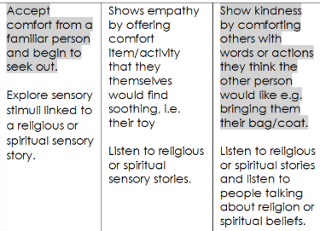
RSE
Strand: Relationships
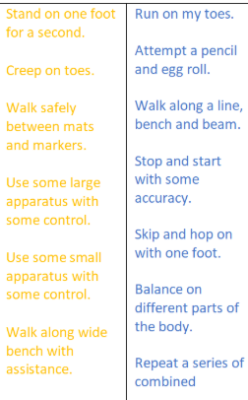
To support pupils to have a voice we will use…
PECs, communication books, Makaton, choices
MY WORLD
Strand: citizenship

