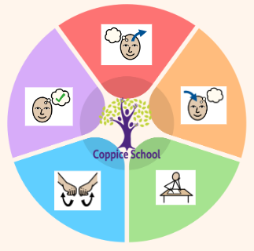
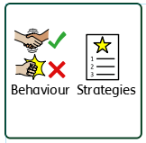
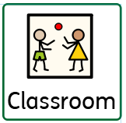
E3
To support behaviours in our class you will see the following strategies: Clear routines, firm expectations, expected role modelling, time out.
In our learning environment, displays and provision we are trying to support and facilitate the following knowledge and skills; Independence, appropriate interactions, solving problems and developing tolerance and patience.
Class: J7
Pathway: Formal
Term: Summer 1 2026
Books: Jump into Jobs: Working with animals, The reasons I jump.

Good Health and Wellbeing
Friends, Relationships
&Community
Engage in discussions E1, Building Confidence and Self-esteem E2, Assertiveness and decision making E3, Engage in discussion L1

Shopping, using public transport

Kitchen hygiene
Friends, Relationships and Community
Recognising how working alongside others can help us
Employability
Healthy eating, healthy lifestyles
Independent Living
Overarching EHCP
Life-Long learning
Developing Independence

Theme:
Animal Antics

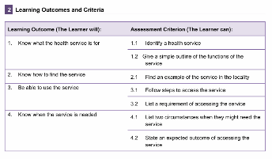
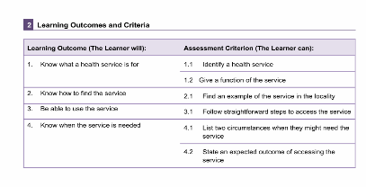
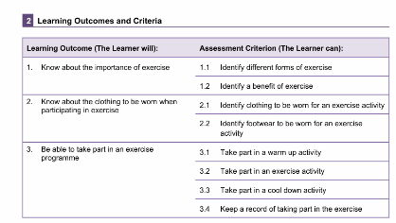
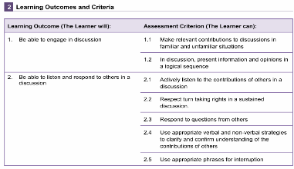
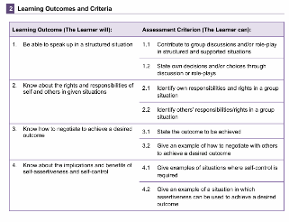
E2
E1
E3
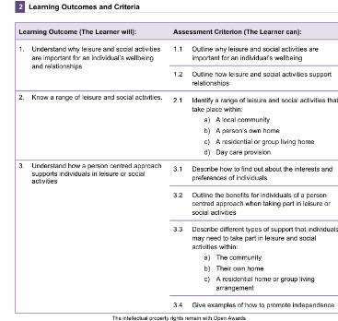
L1
Good Health & Wellbeing
Health and fitness E1, Accessing health services E2 and E3, Understand the Importance of Engagement in Leisure and Social Activities in Health and Social Care L1
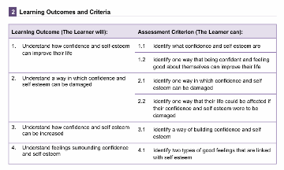
E2
Open Awards
Employability
Following instructions E1, E2, E3, Communication Skills for group and teamwork L1
L1
Open Awards

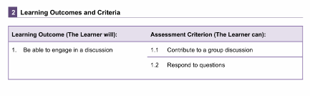
E1

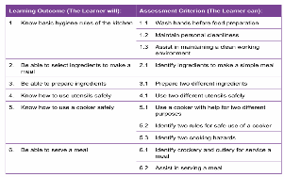
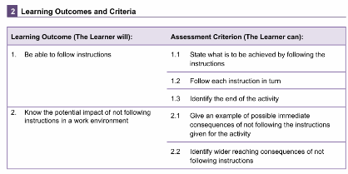
Open Awards
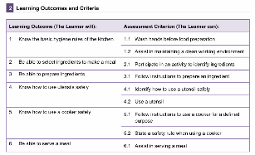
E2
Happy Centred Schools Driver
Skills Builder Driver
Independent Living
Strand: Kitchen Hygiene
Class Focus: Make a Meal E1, E2 and E3, Menu Planning L1

Travel training, accessing community with friends
E2
E1
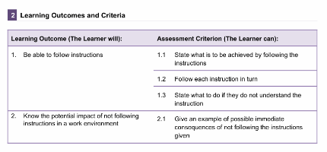
E1
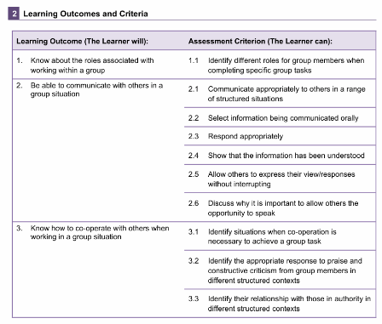
Open Awards
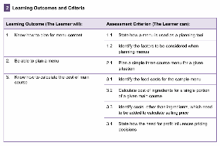
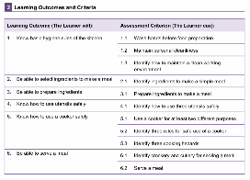
E3
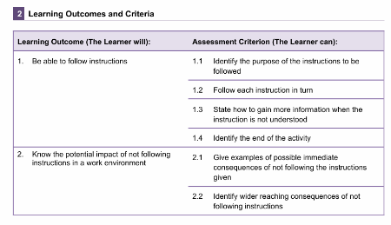
L1
L1
E3
Maths Functional Skills – Open Awards – E1, E2, E3, L1
Strand: Number, Geometry
Class Focus: using +,-,x and /, properties of shapes, converting length and weight.

Composite Half Termly End Point (Number weeks 1-3)
Recognise and interpret the symbols +, – and = appropriately
Approximate by rounding to the nearest 10, and use this rounded answer to check results
Divide three-digit whole numbers by single- and double-digit whole numbers and express remainders
Use multiplication facts and make connections with division facts
Communication Half Termly End Point:
I can communicate about something that has happened or will happen with help.
I can use pictures or symbols to describe a simple event in order.
I can make clear statements and share my feelings and opinions on a straightforward topic.
I can clearly express information and communicate my feelings and opinions about a topic.

English Functional Skills – Open Awards – E1, E2, E3, L1

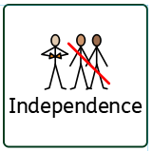
To support pupils to develop independence we encourage… children to collect their own resources, follow tasks with minimal guidance, look after themselves and manage disagreements between themselves.
Composite Half Termly End Point (Geometry weeks 4-6)
Describe and make comparisons in words between measures of items including size, length, width, height, weight and capacity
Describe the properties of common 2-D and 3-D shapes, including numbers of sides, corners, edges, faces, angles and base
Compare metric measures of length, including millimetres, centimetres, metres and kilometres
Convert between units of length, weight, capacity, money in the same system
Reading Half Termly End Point:
I can create my own story from a sequence of pictures.
I can read simple sentences containing one clause.
I can understand organisational markers in short, straightforward texts.
I can use organisational and structural features to locate relevant information in a range of straightforward texts. Read words with silent letters.

Writing Half Termly End Point:
I can write a simple sentence - I can plan a story using pictures.
I can write simple sentences to communicate information clearly - I can use capital letters for ‘I’ and the first letter of proper nouns.
I can use basic punctuation correctly, including full stops, capital letters, question marks and exclamation - marks I can use adjectives and simple linking words appropriately in my writing.
I can use a range of punctuation correctly, including full stops, question marks, exclamation marks, commas and possessive apostrophes - I can write text with the right level of detail and length to suit the purpose and audience.

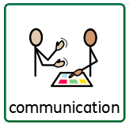
To support pupils to have a voice we will use… ensure that we are listening carefully when it is other people’s turn to speak, encourage students to have the confidence to share their thoughts/ideas.

