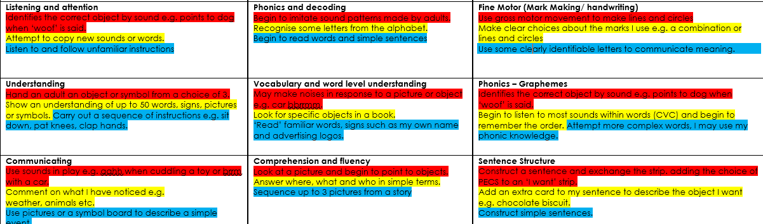
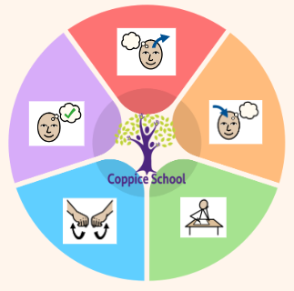
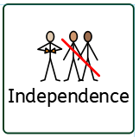
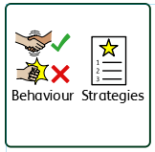
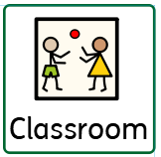
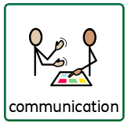
Books:
Footprint – Phil Cummings
• Wildlife: The extraordinary
adventure of David
Attenborough
Composite Half Termly End Point:
Red: Demonstrate an appreciation of stillness and quiet
Yellow: Engage in moments of reflection.
Blue: Demonstrate a basic understanding of what is right and wrong in familiar situations, evaluating own actions and begin to understand consequences.
Science
Strand: Animals
Class Focus: 3D model

Composite Half Termly End Point:
Red: Begins to know / recognise familiar animals.
Yellow: Copies adults actions or sounds using small world animals
Blue: Comment on what they see in the natural world in relation to animals and their habitats
Composite Half Termly End Point:
Red: Is able to explore their immediate environment.
Yellow: Enjoys playing with small world models e.g. farm, jungle, ocean
Blue: To know some vocabulary to describe the characteristics of different places where animals live.
Composite Half Termly End Point:
Red: Explore and experiment with a range of media through sensory exploration and actions
Yellow: Stick two surfaces together when model making.
Blue: Create simple representations of events, people and objects.
Class: J6
Pathway: Semi-formal
Term: Summer 1
Composite Half Termly End Point:
Red: Begin to show recognition of familiar environments.
Yellow: Have an awareness of my similarities and differences in relation to my family and friends.
Blue: Communicate about and show an awareness of the similarities and differences in relation to my friends or family.
Composite Half Termly End Point:
Red: Show awareness of obstacles.
Yellow: Jump forwards with two feet together.
Blue: Run with speed, effort control and direction.
PE
Strand: Athletics

DT

Composite Half Termly End Point:
Red: Accept a variety of textures; fizzy, wet, dry
Yellow: Change food or drink (e.g. add squash, juice to change colour.)
Blue: purposefully manipulates foods to achieve a planned effect
Red:
Yellow:
Blue:
ART
Strand: 3-D
Class Focus: 3D animal model

RE

Geography
Strand:
Class Focus:

ENGLISH
Class Focus: Footprints

Strand 1:
Half Termly End Point:

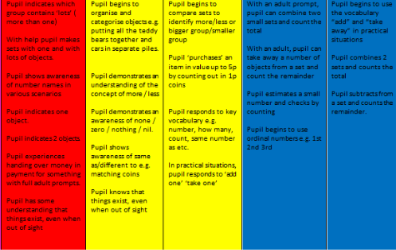

MATHS

Composite Half Termly End Point:
Red: Show an awareness of body parts.
Yellow: Point to main body parts on request.
Blue: Remember and recall details
To support pupils to develop independence we encourage them to be as independent as possible throughout the whole school day
To support pupils to have a voice we will use PECS and Makaton.
To support behaviours in our class you will see a range of bespoke strategies.
In our learning environment, displays and provision we are trying to support and facilitate the following knowledge and skills;

Cognition & Learning

Social, Emotional & Mental Health

Communication & Interaction
Physical & Sensory
Overarching EHCP
Life-Long learning
Developing Independence
RSE
MY WORLD
PSHE
Theme:
Animal Antics

Happy Centred Schools Driver
Coping

