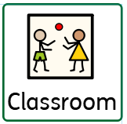
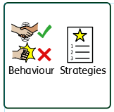
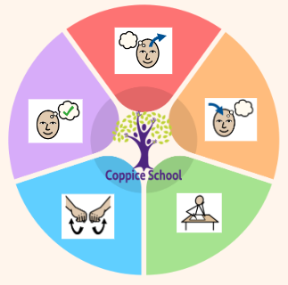
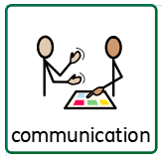
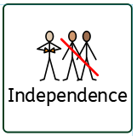
Meerkat Mail
Jonty the Penguin
Colour Monster
Reading Half Termly End Point:
Red: Begin to imitate sound patterns made by adults. Show some awareness of the print in the environment. Select a few familiar words, pictures or symbols when presented in a familiar way. May make noises in response to a picture or object e.g. car bbrrmm. Recognise that pictures tell a story. Look at a picture and begin to point to objects. Try to find a favourite book.
Yellow – Recognise some familiar words. Recognise some letters from the alphabet. Indicate to other words that have the same letter as my name. Look for specific objects in a book. Name objects in a book – by pointing/matching. Give meaning to some environmental sign, symbol or text. Answer where, what and who in simple terms. Fill in the missing words or phrase from a known rhyme/simple story.
Blue

Communication Half Termly End Point:
Red - Understand and respond to a simple request with gesture. Identifies the correct object by sound e.g. points to dog when ‘woof’ is said. Hand an adult an object or symbol from a choice of 3. Respond appropriately to simple requests such as ‘clap your hands.’ Demonstrate an understanding of 10-20 familiar words, pictures or signs. Use a single word, sign or symbol to convey an immediate choice of activity. Try to get an adults attention for amusement. Make a choice between two symbols or objects.
Yellow: Fill in the missing word in a rhyme. Attempt to copy new sounds or words. Join in with a sound bingo / lotto game. Show an understanding of up to 50 words, signs, pictures or symbols. Understand up to 10 verbs. Begin to understand the words for emotions. Show an understanding of more complex sentences.

Writing Half Termly End Point:
Red: Use gross motor movement to make lines and circles. Use a mark making tool to make scribbles and dots. Use my index finger to make marks. Begin to understand that marks have some meaning and begin to make some marks. Shows awareness of rhythm and rhyme e.g. moving body. Identifies the correct object by sound e.g. points to dog when ‘woof’ is said. Construct a sentence and exchange the strip. – just adding the choice of PECS to an ‘I want’ strip. Make a choice between a preferred and non-preferred symbol/ picture. Choose between several cards to make a choice. Use a mark making tool to make scribbles and dots.Put marks and symbols alongside a picture or photo.
Yellow: Begin to copy marks made by an adult. Make clear choices about the marks I use e.g. a combination or lines and circles. Show an awareness that letters carry meaning. Make letter like marks in sensory media. Begin to listen to most sounds within words (CVC) and begin to remember the order. Listen as an adult models oral

Composite Half Termly End Point:
.
Yellow: Begin to recognise and matches animals and objects to picture. Moves an object along a map. Enjoys playing with small world models e.g. farm, jungle, ocean

Art 3D

Composite Half Termly End Point:
Yellow: Make models using malleable media. Select a tool for a purpose and communicate what it does (e.g., cut, stick). Stick two surfaces together when model making. Select a variety of materials for work.

Geography

Composite Half Termly End Point:
Yellow: Name easily recognisable emotions. Independently access material/equipment or environment to fulfil sensory /emotional needs or communicates that need to an adult. Knows which person to seek out to find help and support in different environments, eg, playground or classroom.
Blue Express my feelings in a non-aggressive manner. Independently access appropriate coping techniques. Accept support from a familiar adult to engage in distraction activity/therapy.
Composite Half Termly End Point:

Yellow: Copies adults’ actions or sounds using small world animals. Demonstrates use and function of a familiar object e.g. feed bucket, animal food. Begins to notice detailed features about animals

Composite Half Termly End Point:
Yellow: Respond to a few appropriate boundaries with encouragement and support. Show an understanding of the cause of some feelings (e.g. feel sad or frustrated when I can’t go out to play.) Shows some awareness of others’
Blue - Use gesture, symbols or words to tell someone that I am uncomfortable, hurt unwell, or in pain. Retell a simple past event in the correct order. Communicate in order to sequence and clarify my thinking, ideas, feelings and thoughts.

Composite Half Termly End Point:

Yellow Sort food/drink based on a single criterion. Change food or drink (e.g. add squash, juice to change colour.) Demonstrate use and function of familiar foods.

Composite Half Termly End Point:

Yellow: Name easily recognisable emotions. Independently access material/equipment or environment to fulfil sensory /emotional needs or communicates that need to an adult. Knows which person to seek out to find help and support in different environments, eg, playground or classroom.
Blue Express my feelings in a non-aggressive manner. Independently access appropriate coping techniques. Accept support from a familiar adult to engage in distraction activity/therapy

Strand 1: Number Set 2
Half Termly End Point:
Red: Pupil shows awareness of number names in various scenarios Pupil experiences handing over money in payment for something with full adult prompts. Pupil indicates one object. Pupil indicates 2 objects.
Yellow: Level 1: Pupil shows awareness of same as/different to e.g. matching coins. Pupil demonstrates an awareness of none / zero / nothing / nil. Level 2: pupil ‘purchases’ an item in value up to 5p by counting out in 1p coins In practical situations, pupil responds to ‘add one’ ‘take one’
Red: Pupil combines objects to make simple constructions.
Yellow: Pupil manipulates 2D/3D shapes. Pupil begins to build using 2D/3D shapes

To support pupils to develop independence we encourage Children to help themselves trying to put on their own clothes and accessing their own resources
Science

HCS

RSE
Theme: Animal Antics

In our learning environment, displays and provision we are trying to support and facilitate the following knowledge and skills;
To support behaviours in our class you will see the following strategies: redirecting, distraction methods, modelling and supporting with key words.
Class: Oak
Pathway: Informal/ Semi-Formal
Term: Summer 1
MY WORLD
ENGLISH

To support pupils to have a voice we will use…
Food DT

MATHS

Cognition & Learning

Social, Emotional & Mental Health

Communication & Interaction
Physical & Sensory
Overarching EHCP
Life-Long learning
Developing Independence
PSHE

Happy Centred Schools Driver:
Coping and Positive Relationships

