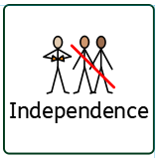
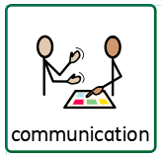
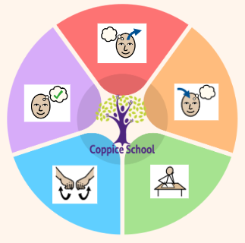
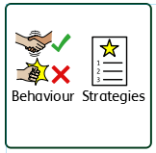
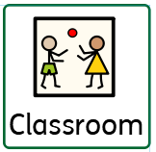
Composite Termly End Point
Geography

Composite Half Termly End Point:
RE

Composite Termly End Point
DT – My Cooking

Composite Half Termly End Point:
MY WORLD
Composite Half Termly End Point:
RSE

Composite Termly End Point
Art
3D

Physical & Sensory
Composite Termly End Point
Science
Animals

Theme:
Animal Antics
Sensory circuits, movement breaks
Work first then, BLQ, purchasing snack
To support behaviours in our class you will see the following strategies:
Deep pressure, timers for reflection time, movement breaks, change of face, planned ignoring where needed, team teach, firm voices, symbols and minimal language, consistency. Break out spaces.

MATHS

To support pupils to have a voice we will use…
communication boards, PECS, Makaton, simple language, sentence strips, communication books
To support pupils to develop independence we encourage…
Collect own resources with PECS, personal care, drinks station, independent changing - swimming and PE
Class: J1
Pathway: Semi-Formal
Term: Summer 1
In our learning environment, displays and provision we are trying to support and facilitate the following knowledge and skills;
Communication, exploring new activities, phonics and maths skills, independence, self-regulation, love of reading.
Changing, walking to the shop
PECs, turn taking, sharing, HCS
Cognition & Learning
Social, Emotional & Mental Health
Communication & Interaction
Overarching EHCP
Life-Long learning
Developing Independence
PSHE

Happy Centred Schools Driver
Coping

