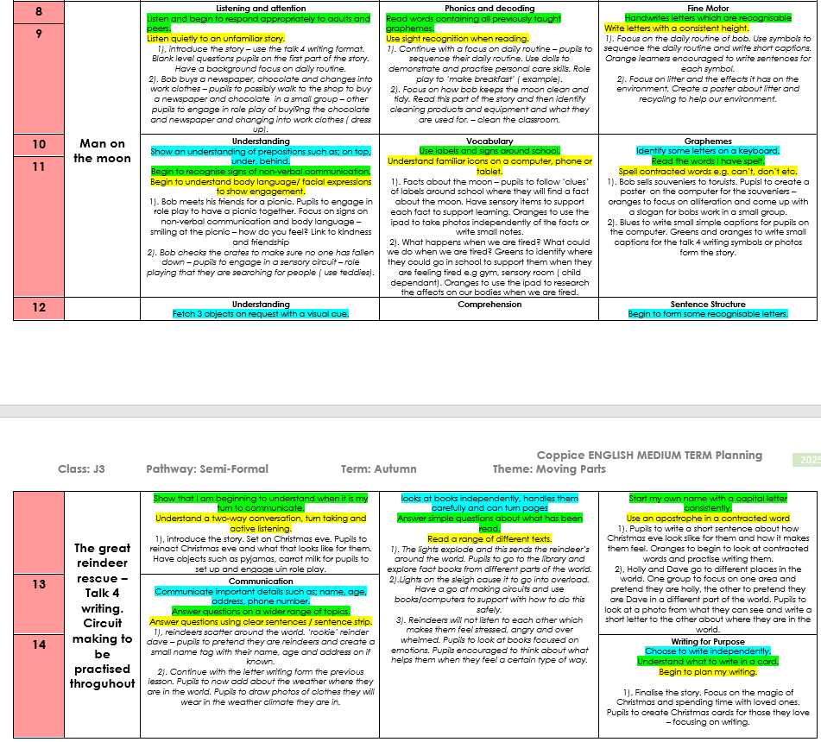
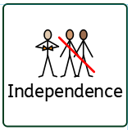
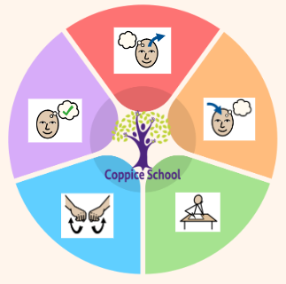
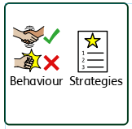
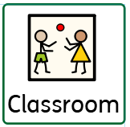
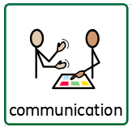
DT
Strand: Cooking
Class Focus: Using different appliances and identify ingredients

Composite Half Termly End Point:
Blue: Show kindness by comforting others with words or actions they think the other person would like e.g. bringing them their bag/coat
Green: Engage in small acts of kindness by sharing or giving small gifts and understand probable emotional reactions.
Orange:. Follow example of how to show kindness to living things and their environment

Composite Half Termly End Point:
Blue: To think about their likes, interests, learning strengths and achievements and present their personal aspirations for the future.
Green: To review their likes, interests, learning strengths and achievements and discover how these link with different types of jobs.
Composite Half Termly End Point:
Blue: Make objects and crafts that move by using various methods, including pressing, turning or lifting elements
Green: Know some facts about the Sun, the Moon and some other planets (space).

Composite Half Termly End Point:
Green: Begins to follow road safety instructions
Orange: Explains how to keep safe when travelling.
Strand 1: Number set 2
Green: add and subtract single digit numbers in everyday situations.
Orange: add and subtract two-digit whole numbers in everyday situations.

Strand 2: Data handling set 1
Blue : To record simple sorting activities using pictorial representation on simple diagrams e.g. Venn, Carroll.
Green: read and draw simple charts and diagrams, including a tally chart, block diagram/graph.
Orange: interpret and construct tally charts.

Composite Half Termly End Point:
Orange: Be able to select and prepare ingredients for three simple dishes.

Composite Half Termly End Point:
Blue: Show confidence in using construction kits including some complex actions (e.g. wheels.
Green: Follow a simple plan
Orange: Use a range of design techniques in using colour, pattern, form and space.
Composite Half Termly End Point:
Green: Identify the people who love and care for me and how they help me feel cared for
Orange: Understand that all families vary and no family is the same.

Books: Dumplin, The man on the moon, The great reindeer rescue

DT
Strand: Materials
Class Focus: Design a moving object

ENGLISH
Class Focus: See table

To support pupils to develop independence we encourage…
Personal care, walking to the local community to purchase snacks
Science
Strand: Forces
Class Focus: Understand how objects move.

To support pupils to have a voice we will use…
Communication books, PECS, now and next, communication boards
Geography
Class Focus: Follow directional instructions and keep safe.

PECS, communciation books
Personal care, Walking to the shop
Work first, now and next, BLQ
Gym, Movement breaks,PE
MY WORLD
PE
Strand:

RE

MATHS

To support behaviours in our class you will see the following strategies: Planned ignore, sand timers, now and next, working for strips,
Class: J3
Pathway: Semi-formal
Term: Autumn 2
In our learning environment, displays and provision we are trying to support and facilitate the following knowledge and skills; Phonics, a love for reading, zones of regulation and working walls.
Cognition & Learning
Social, Emotional & Mental Health
Communication & Interaction
Physical & Sensory
Overarching EHCP
Life-Long learning
Developing Independence
RSE
PSHE
Theme:
Moving Parts

Happy Centred Schools Driver:
Positive relationships

