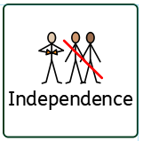
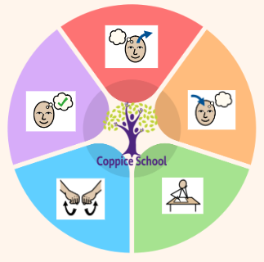
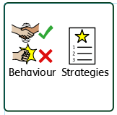
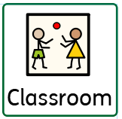
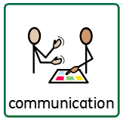
Science
Strand: Forces
Class Focus: Understand how objects move.

Composite Half Termly End Point:
Yellow: Show affection and concern for people who are special to me.
Green: Identify the people who love and care for me and how they help me feel cared for
Orange: Understand that all families vary and no family is the same.

Geography
Class Focus: Follow directional instructions and keep safe.

Composite Half Termly End Point:
Yellow: Is able to move around the school with adult support.
Green: Begins to follow road safety instructions
Orange: Explains how to keep safe when travelling.
Composite Half Termly End Point:
-improving ways of communicating
-continue to improve writing skills
-build on reading and comprehension
Composite Half Termly End Point:
Yellow: Shows empathy by offering comfort item/activity that they themselves would find soothing, i.e. their toy
Blue: Show kindness by comforting others with words or actions they think the other person would like e.g. bringing them their bag/coat
Green: Engage in small acts of kindness by sharing or giving small gifts and understand probable emotional reactions.
Orange:. Follow example of how to show kindness to living things and their environment

Composite Half Termly End Point:
Yellow: initiate the exploration of objects that can be pushed/ pulled or switched on
Blue: Make objects and crafts that move by using various methods, including pressing, turning or lifting elements
Green: Know some facts about the Sun, the Moon and some other planets (space).

ENGLISH
Class Focus: See table

To support behaviours in our class you will see the following strategies: Planned ignore, sand timers, now and next, working for visuals, using safe space, quiet space,
DT
Strand: Cooking
Class Focus: Using different appliances and identify ingredients

Composite Half Termly End Point:
Yellow: Take on small responsibilities that help the class or community (e.g., watering plants, handing out cups)
Blue: Identify some simple ways in which we can take care of people / animals / the environment.
Green: To explain how and why we need to look after our school environment, and play an active part in looking after it.
Strand 1: Number set 2
Yellow: match quantities and recognise numbers up to 5
Blue: work out totals when adding two groups.
Green: add and subtract a single digit numbers in everyday situations.
Orange: add and subtract two-digit whole numbers in everyday situations.

Strand 2: Data handling set 1
Yellow: recognising 2D shapes
Blue : To record simple sorting activities using pictorial representation on simple diagrams e.g. Venn, Carroll.
Green: read and draw simple charts and diagrams, including a tally chart, block diagram/graph.
Orange: interpret and construct tally charts.

Composite Half Termly End Point:
Orange: To be able to select and prepare ingredients for three simple dishes.

Composite Half Termly End Point:
Yellow: Begin to connect construction kits together.
Blue: Show confidence in using construction kits including some complex actions (e.g. wheels.
Green: Follow a simple plan
Orange: Use a range of design techniques in using colour, pattern, form and space.

Books: Dumplin, The Man on the Moon, The Great Reindeer Rescue

DT
Strand: Materials
Class Focus: Design a moving object

To support pupils to develop independence we encourage…finding resources independently, following toileting programmes, hand washing
To support pupils to have a voice we will use…
Communication books, PECS, now and next, communication boards, Makaton
PECS, communciation books
Personal care, Walking to the shop
Work first, now and next, BLQ
Gym, Movement breaks,PE
MY WORLD
PE
Strand: Gymnastics,
Led by Active Fusion

RE

MATHS

Class: J4
Pathway: Semi-formal
Term: Autumn 2
In our learning environment, displays and provision we are trying to support and facilitate the following knowledge and skills; Phonics, a love for reading, zones of regulation and working walls.
Cognition & Learning
Social, Emotional & Mental Health
Communication & Interaction
Physical & Sensory
Overarching EHCP
Life-Long learning
Developing Independence
RSE
PSHE
Theme:
Moving Parts

Happy Centred Schools Driver:
Positive relationships

