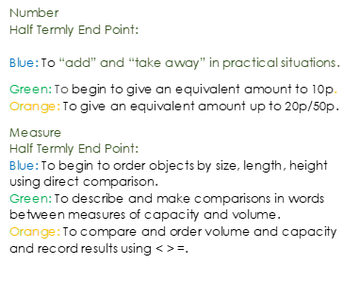
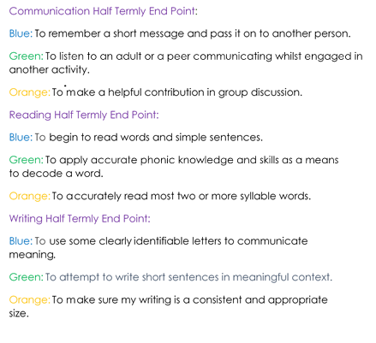
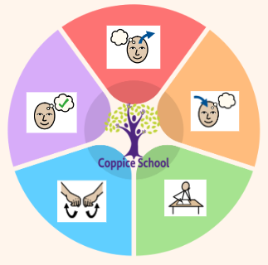
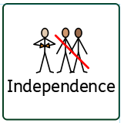
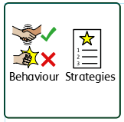
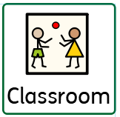
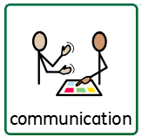
Gym, Movement breaks,PE
Composite Half Termly End Point:
Blue: Demonstrate a basic understanding of what is right and wrong in familiar situations, evaluating own actions and begin to understand consequences.
Green: Demonstrate an understanding of what is right or wrong in in day to day situations and stories.

Composite Half Termly End Point:
Blue: Weave using simple materials.
GREEN Complete simple weaving with warps in place.
Orange: Describe patterns.
Composite Half Termly End Point:
Blue: Can identify common animal
sounds and name simple body parts.
Green: Names and recognises a range of animals from around the world and can identify more complex body parts. E.g. flippers and gills.

Books:
Little People, Big Dreams- Louise Braille
The Boy at the back of the class

SCIENCE
Strand:
Class Focus: Identifying historical events and figures.

Composite Half Termly End Point:
Blue: Name some habitats and describe what they see, hear and feel.
Green Identify likes and dislikes of a place (habitats).

ENGLISH

GEOGRAPHY
Class Focus: Habitats around the world

Composite Half Termly End Point:
Blue: Show that I know how to behave safely.
Green: Know what an emergency is (e.g. someone is badly hurt, very ill or has had a serious accident.).

ART 3D
Strand: Cooking
Class Focus: Choosing items, preparing and cooking a variety of food.
Composite Half Termly End Point:
Blue: Show some understanding that good exercise, sleeping, eating and hygiene contribute to good health.
Green: Understand what is important in order to maintain a healthy body.
To support pupils to develop independence we encourage…
Personal care, looking for resources
To support pupils to have a voice we will use…
Communication books, PECS, now and next, communication boards

PECS, communciation books
Personal care, Walking to the shop
Work first, now and next, BLQ
MY WORLD
PE
Strand: Athletics

RE

MATHS

To support behaviours in our class you will see the following strategies: Planned ignore, sand timers, now and next, working for strips, distraction, redirection, a change of face
Class: J4
Pathway: Semi-formal
Term: Summer 1
In our learning environment, displays and provision we are trying to support and facilitate the following knowledge and skills; Phonics, a love for reading, meditation, calming breathing.
Cognition & Learning
Social, Emotional & Mental Health
Communication & Interaction
Physical & Sensory
Overarching EHCP
Life-Long learning
Developing Independence
RSE
PSHE
Theme:
Helpers and heroes

Happy Centred Schools Driver:
Support

