Outdoor Learning Ideas | 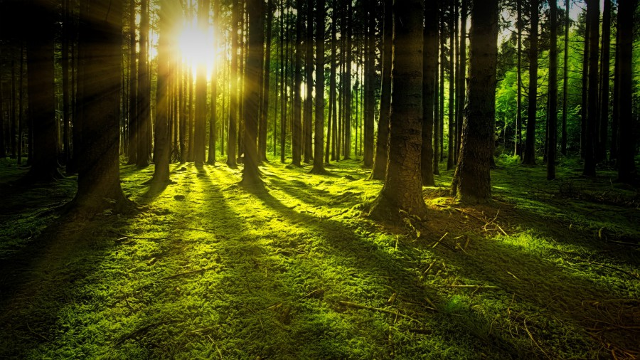  Make a natural bird feeder.  This could be a recycled bottle feeder, or could be seeds left out for the birds.  https://www.youtube.com/watch?v=7yV6V6rtpyc  https://www.youtube.com/watch?v=_AtclnI5ABg | Spot birds in your garden.  Spend some time in your garden or looking through your window and try to count as many different kinds of birds you can. Can you work out which birds they are?  https://www.rspb.org.uk/birds-and-wildlife/ | Signs of spring.  - What things LOOK spring?  - What things SOUND spring?  - What things SMELL spring?  - How does spring FEEL?  - What things TASTE spring?  - What EXPERIENCES or IDEAS seem spring?  http://www.treetoolsforschools.org.uk/activities/pdfs/pdf_first_signs_of_spring.pdf
Create a weather diary for a week.  Draw a symbol for the weather each day.  Can you work out what clothes you need for different types of weather?  http://www.treetoolsforschools.org.uk/activities/pdfs/pdf_weather_diary.pdf | Go on a mini-beast hunt outside your home.  Draw or record what you find. How many creepy crawlies are there in your garden or park?  http://www.treetoolsforschools.org.uk/activities/pdfs/pdf_creepy_crawly_spotter_sheet.pdf | Where is your favourite outdoor space?  Go out to a park or woodland and see what you can find while you are there. You could make a journey stick to remember your visit or draw/craft a picture to remind yourself  https://www.nationaltrust.org.uk/  http://www.treetoolsforschools.org.uk/activities/pdfs/pdf_journey_stick.pdf | Build a den and have a picnic outside.  Use old sheets or blankets and chairs, clothes airers or carboard boxes to build a den just for you. Make some sandwiches and have a picnic in your shelter.  https://www.edenproject.com/learn/for-everyone/how-to-build-your-own-den
Go on an egg box scavenger hunt.  Can you find something for each section of your egg box? Set your own challenges or use the download here:  http://www.treetoolsforschools.org.uk/activities/pdfs/pdf_egg_box_scavenger_hunt.pdf | Make a mud creature outside or inside.  Use an old tray to hold some soil or compost. Add water and enjoy the mud play. Use leaves and twigs to make features and give your mud creature a name.  http://www.treetoolsforschools.org.uk/activities/pdfs/pdf_mud_creatures.pdf | Challenge yourself to complete the woodland Olympics.  Visit a park or woods and find as many different ways of moving over, under and round obstacles.  http://www.treetoolsforschools.org.uk/activities/pdfs/pdf_woodland_olympics.pdf | Make a woodland potion and magic wand.  Use a twig to make a Harry Potter style wand, then use whatever natural materials you can find mixed with water to make different potions.  http://www.treetoolsforschools.org.uk/activities/pdfs/pdf_magic_wand.pdf  http://www.treetoolsforschools.org.uk/activities/pdfs/pdf_woodland_potions.pdf

