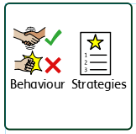
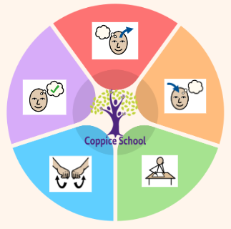
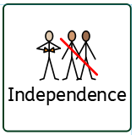
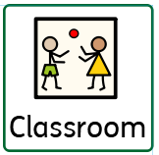
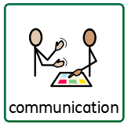
Strand 1: Number set 2
Half Termly End Point:
Blue: Pupil can take away a number of objects from a set and count the remainder with support
Green: Begin to give an equivalent amount to 10p.
Orange: Recognise all coins up to 50p, give an equivalent amount up to 50p.

Composite Half Termly End Point:
Blue: I can communicate about my home and family.
Green: Understand change and loss, feelings associated with this and what helps people feel better.
Orange: Understand it is important to tell a trusted adult if something about my family makes me unhappy or worried.

MY WORLD
Strand: Citizenship - belonging to a community.

Composite Half Termly End Point:
Yellow: Explore pouring with physical support.
Blue: Pour ingredients independently.
Green: Identify why it is important to be safe and hygienic in the kitchen.
Orange: Be able to select and prepare ingredients for three simple dishes.

Composite Half Termly End Point:
Blue: Show pride in helping others.
Green: Appreciate the importance of school to me and how we can make school a safe, happy place.
Orange: Understand why and show that I can treat people with respect and kindness, regardless of our differences.

Composite Half Termly End Point:
Yellow: Recognise and respond to a variety of religious and spiritual images and objects.
Blue: Listen to religious stories
Green: Begin to communicate ideas, feelings or responses to experiences or to re-tell religious or spiritual stories

RE
Strand: Kindness

Composite Half Termly End Point:
Yellow: Understand what objects/toys are used for with an adult’s support.
Blue: Make objects and crafts that move by using various methods, including pressing, turning or lifting elements.
Green: Know some facts about the Sun, the Moon and some other planets (space).
Orange: Explain about gravity and forces on Earth and how this affects other parts of the solar system.

Composite Half Termly End Point:
Yellow: Can make a choice about their destination.
Blue: Discusses familiar routes.
Green: Knows the direction to get home from local familiar places.
Orange: Explains how to keep safe when travelling.
RSE
Strand: Relationships and families
Communication Half Termly End Point:
Blue: Attempt to correct misunderstandings without changing the words e.g. repeating words.
Green: Begin to answer ‘how’ and ‘why’ questions. – may only be one word.
Orange: Answer questions on a wide range of topics

Reading Half Termly End Point:
Blue: Look at books independently, handles them carefully and turns pages.
Green: Express an opinion about a story / character.
Orange: Read a range of different texts.
Writing Half Termly End Point:
Blue: Write/type a list.
Green: Use the capital I pronoun.
Orange: Use commas in a list

Theme:
Moving parts
Books:
Look up- Nathan Byron
Russell’s Christmas magic – Rob Scotton
Julian is a mermaid – Jessica Love

Personal hygiene, emotional regulation, social skills
Signing, communication books, intensive interaction.
Strand 2: Data handling
Half Termly End Point:
Blue: Begin to understand the use of sorting within practical contexts.
Green: Read and draw simple charts
Orange: Interpret and construct simple pictograms

MATHS
Strand 1: Number set 2

Strand 2: Data handling
Set 1

Composite Half Termly End Point:
Yellow: Make simple structures with adult support.
Blue: Construct with a purpose in mind, using a variety of resources (e.g. make a representation of event, person or object.)
Green: Communicate about how their products will look, how they are making it and their finished product using either words, symbols, drawing or labels.
Orange: Communicate about how their products will work using either words, symbols, drawing or labels.

Composite Half Termly End Point:
Yellow: Walk along wide bench with assistance.
Blue: Repeat a series of combined actions.
Green: Create and perform a short sequence.

PE
Strand: Gymnastics

To support pupils to develop independence we encourage…
Self-help, personal hygiene, independence, dressing, eating and making own snacks and drinks.
Science
Strand: Forces

Geography
Strand: Directions

In our learning environment, displays and provision we are trying to support and facilitate the following knowledge and skills;
Independence, communication and engagement.
To support behaviours in our class you will see the following strategies: Countdowns, positive reinforcement, individualised boards, embedded routines, communication books.
ENGLISH

DT
Strand: Cooking

DT
Strand: Materials

To support pupils to have a voice we will use…
Makaton, symbols, visuals, AAC’s, communication books
Class: Rowan
Pathway: Woodlands
Term: Autumn 2
Work first, routines, timers, TEACCH, overlearning
Cognition & Learning
Sensory integration, PE,
learning through movement
Social, Emotional & Mental Health
Communication & Interaction
Physical & Sensory
Overarching EHCP
Life-Long learning
Developing Independence
PSHE

Happy Centred Schools Driver
Confidence

