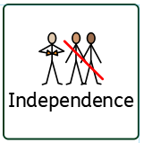
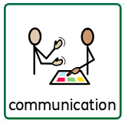
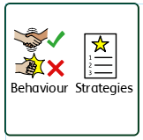
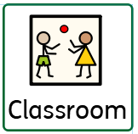
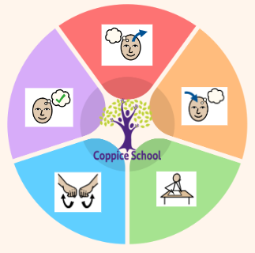
Achievement and success
coping
support
We prepare for the future
Happy Centred Schools Driver
positive relationships/ confidence
Moving Parts
Class: J5
Pathway: informal
Term: Autumn 2025
Communication/interaction-
PECS
Makaton
Visual aids
Auditory aids
Routine
Emergent writing/mark making
Imperative communication
Declarative communication
Intensive interaction

We try our best
We are kind
Cognition and learning-
Systematic instruction
Phonics
Sharing stories/books
Developing communication skills
Developing writing
Learning about the world around us (theme)
Community visits
Meaningful experiences (math)

Physical and sensory-
Sensory diets
Shabang
TacPac
Song/story massage
Hands on exploration
PE
Swimming
Outside movement
Forest school
cooking
To support pupils to have a voice we will use… body gesture, facial gesture, PECS, Makaton, behavioural expression
To support pupils to develop independence we encourage… Personal care, hygiene, feeding, preparation of food, dressing and trips within the community

To support behaviours in our class you will see the following strategies: : sensory diet, therapies, movement, appropriate demands, child-initiated learning, processing time

In our learning environment, displays and provision we are trying to support and facilitate the following knowledge and skills; independence, sharing and cooperation, understanding, tolerance, acceptance

Engagement –
Exploration
Realisation
Anticipation
Persistence
Initiation
Independence –
Shopping
Cooking
Breakfast/snack
Tidying
Dressing/undressing
Toileting
Feeding
Executive function
SEMH-
Sharing
Turn taking
Games
Waiting
Regulation
Safe spaces
Interaction
Emotional literacy

1-1 work
food
outside
Songs
whiteboard
Tactile experiences
tolerant
confident
regulated
voice
Overarching EHCP
Life-Long learning
Engagement
Physical & Sensory
Cognition & Learning
Developing Independence
Social, Emotional & Mental Health
Communication & Interaction

