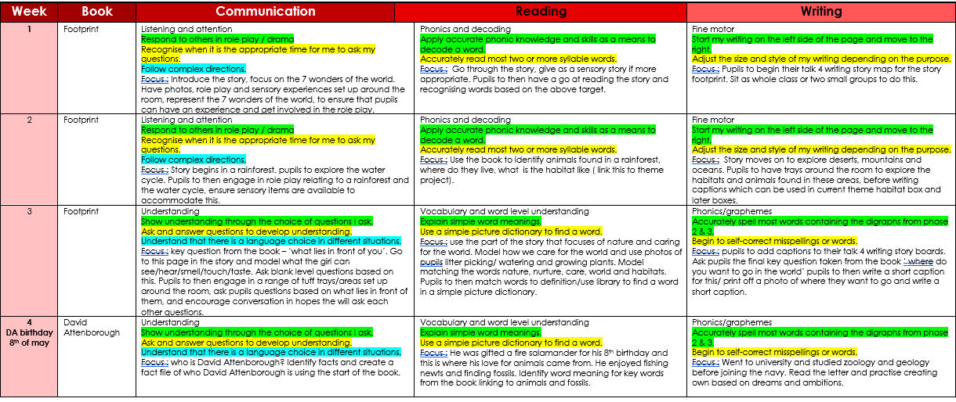
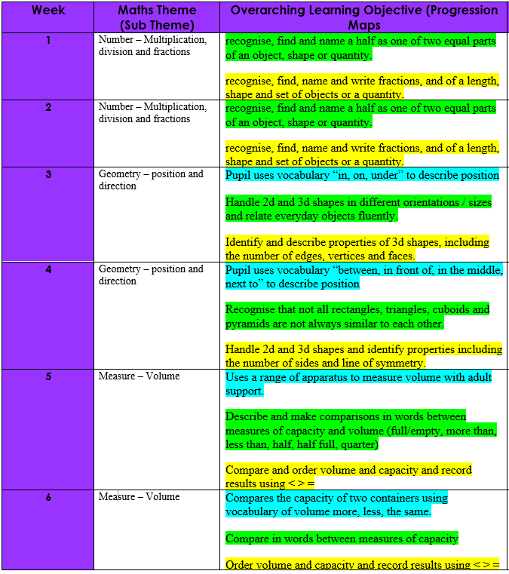
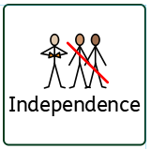
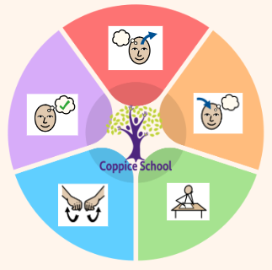
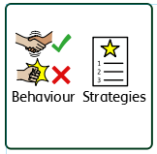
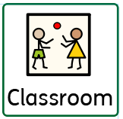
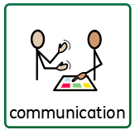
Composite Half Termly End Point:
Orange: Name and sort most foods into the five groups. Plan and cook a meal that reflects healthy eating advice.

Science
Strand:
Class Focus: working towards class project creating habitats.

Composite Half Termly End Point:
Green: Names and recognises a range of animals from around the world and can identify more complex body parts. E.g. flippers and gills. Know and classify common animals including fish, amphibians, reptiles, birds and mammals. Explain what animals need to live and be able to them according to their diets. Carnivores, herbivores and omnivore.

Composite Half Termly End Point:
Blue: Names some habitats and describe what they see, hear and feel. To know some vocabulary to describe the characteristics of different places where animals live. E.g. desert is hot, the artic is cold. Look at an Atlas or a globe with an adult
Green: Identify likes and dislikes of a place (habitats). Use a simple atlas. Discuss all modes of transport.
Orange: Identify water and land features on a map. Identify sea and land on a globe.

Composite Half Termly End Point:
Blue: Sew large stitches. Create simple representations of events, people and objects. Construct with a purpose and resources in mind. Show a preference for a dominant hand.
Green: Describe the physical world and relate artwork to it. Experiment with colour, design and texture to create visual effects such as adding materials to paint

Composite Half Termly End Point:
Blue: Demonstrate a basic understanding of what is right and wrong in familiar situations, evaluating own actions and begin to understand consequences.
Green: Demonstrate an understanding of what is right or wrong in in day to day situations and stories
Orange: Recognise conflict and peace in their daily lives.
DT
Strand: Cooking
Class Focus: Healthy eating advice and understanding where foods come from.
Composite Half Termly End Point:
Pupils have chosen a careers group. These consist of sing and sign ( choir), Hospitality, Gardening, Imedia and animal care.
Composite Half Termly End Point:
Green: Identify and name body parts including vagina and penis.
Orange: Consider how my life will change as I get older.
Turquoise: Describe what I need to do in a medical emergency.

ENGLISH
Class Focus: See table

Composite Half Termly End Point:
Green:

Art
Strand: 2D and 3D
Class Focus: working towards class project creating habitats.

Books: Footprint, David Attenborough, the reason I jump.

To support pupils to develop independence we encourage…
Personal care, walking to the local community to purchase snacks
To support pupils to have a voice we will use…
Communication books, PECS, now and next, communication boards
Geography
Class Focus: working towards class project creating habitats.

PECS, communciation books
Personal care, Walking to the shop
Work first, now and next, BLQ
Gym, Movement breaks,PE
MY WORLD
PE
Strand: Athletics

RE

MATHS

To support behaviours in our class you will see the following strategies: Planned ignore, sand timers, now and next, working for strips,
Class: J3
Pathway: Semi-formal
Term: Summer 1
In our learning environment, displays and provision we are trying to support and facilitate the following knowledge and skills; Phonics, a love for reading, zones of regulation and working walls.
Cognition & Learning
Social, Emotional & Mental Health
Communication & Interaction
Physical & Sensory
Overarching EHCP
Life-Long learning
Developing Independence
RSE
PSHE
Theme:
Animal antics

Happy Centred Schools Driver:
Coping

